Illinois Junior Academy of Science

Policy & Procedure Manual

September 2018 – August 2020

This Policy and Procedure Manual replaces and supersedes all previous publications.

A copy of this manual should be given to all project sponsors and student participants

This Manual May Be Downloaded from the IJAS Website and Duplicated as Needed

Official Website

www.ijas.org
Aims and Objectives of the Policy and Procedure Manual
The primary aim of this manual is to communicate the information needed by the student and sponsor so that a safe and humane experimental project or paper is presented at the regional and state expositions. Please read this book carefully and resolve any questions before you enter a project or paper.

The Illinois Junior Academy of Science expects all schools and regions to follow all rules, regulations, and guidelines of the state organization. The Illinois Junior Academy of Science will insist that all projects and papers entered into state competition meet all of the rules, regulations, and guidelines of the Illinois Junior Academy of Science. No arbitrary safety procedures or rules may be instituted at the regional level that will limit a school or student's participation at a regional fair and potentially prevent a student advancing to the state level.

Projects that are sent to the State Science Exposition that do not meet the rules, regulations, and guidelines of the Illinois Junior Academy of Science will be disqualified.

The Board of Directors of the Illinois Junior Academy of Science will allow no exceptions to the rules and guidelines as stated in this policy and procedure manual.

Safety rules are not meant to be barriers to progress that have been arbitrarily imposed to make it difficult for students to present a project. The objective of the Policy and Procedure Manual is to provide policies and procedures that are designed for the safety of the experimenter, as well as the safety of those that will judge and/or view the project.

Join IJAS!

Membership in IJAS is open to all public and private schools, including home schools, in the State of Illinois.

Find out how rewarding participation in IJAS activities can be. Visit us on the web at:
www.ijas.org

Join by December 31 to take advantage of our regular annual membership fee.

Note: All participants in IJAS activities, projects or sessions at the State Exposition must be enrolled in IJAS member schools. IJAS Membership is determined at the state level. No regional rules, regulations, or procedures regarding membership may supersede those of the state. Regions must accept schools placed in their region by the state. Any discriminatory practices against a school, group, or program will not be tolerated.
Policy and Procedure
Manual Editors

Jacki Naughton Kathleen Pericak-
Jann Hawkins Spector
Christina Palffy Sue Ellen Gerchman
Elizabeth Spector

June 2018

This manual may be downloaded
from the IJAS website and duplicated as needed.

The Illinois Junior Academy of Science

Policy and Procedure Manual

Effective September 2018 through August 2020

This Policy and Procedure Manual replaces and supersedes all previous publications

This Policy and Procedure Manual is reviewed and revised every two years. Please note the following changes and modifications from previous years.

- Project Session is now referred to as Poster Session
- All Paper Session entries are submitted electronically
Table of Contents

Topic |  | Page(s)
Aims and Objectives of the Policy and Procedure Manual |  | 2
Table of Contents |  | 3-4
Mission Statement |  | 5
What is a Scientific Exposition? |  | 5
Illinois State Goals and Standards |  | 6
The Science Project – Categories |  | 7-8
Choosing a Topic |  | 9
Using the Scientific and Design Processes |  | 10-12
Rules and Regulations |  | 13-14
Safety Guidelines for Experimentation |  | 14-19
Chemical |  | 14
Electrical and Mechanical |  | 14-15
Fire and Radiation Safety |  | 15
Firearm and Explosive Safety |  | 15-16
Drone Safety |  | 16
Biological |  | 16-19
Use and Care of Humans as Test Subjects |  | 16-17
Use and Care of Non-Human Vertebrates |  | 17-18
Use and Care of Microorganisms |  | 18-19
Special Circumstances/Exceptions |  | 19
Communication |  | 20
Writing a Scientific Research Paper for an Investigation |  | 20
Technical Points of a Scientific Paper |  | 20
Desired Qualities of Scientific Writing |  | 20
The Physical Arrangement of the Written Report (Experimental & Design) |  | 21-23
Oral Presentation |  | 24
Poster Session Display Guidelines/Rules |  | 25
Planning an Attractive Display |  | 25
Paper Session - Rules |  | 26
 | Topic |  | Page(s)
 | Essay Contests |  | 26-27
 | Student Officer Essay Contest |  | 26-27
 | Additional Essay Contests |  | 27
 | Artistic Design Contest |  | 28
 | Judging Criteria for Posters and Papers (Experimental & Design) |  | 29-33
 | Criteria for Experimental Investigations |  | 29
 | Evidence of Experimental Processing Skills |  | 29
 | Scientific Communication – Display |  | 29
 | Scientific Communication - Oral Presentation |  | 29
 | Written Report |  | 30
 | Criteria for Design Investigations |  | 30
 | Evidence of Design Processing Skills |  | 30
 | Scientific Communication – Display |  | 31
 | Scientific Communication - Oral Presentation |  | 31
 | Written Report |  | 32
 | Rating Criteria |  | 32-33
 | Judging Information for the Poster and Paper Sessions |  | 33-34
 | An Overview |  | 33
 | Judging Mechanics |  | 33-34
 | Information for Teachers, Sponsors, and Parents |  | 35-36
 | Information for Sponsors and Teachers |  | 35
 | Information for Parents |  | 36
 | Appendix |  | 37-50
 | Appendix Table of Contents |  | 37
 | Student Project Checklist |  | 38
 | Student Safety Checklist |  | 39
 | APA Resource Websites |  | 40
 | Next Generation Science Standards (NGSS) |  | 41
 | College Readiness Standards (CRS) |  | 42
 | Common Core State Standards (CCSS) |  | 43
 | Official Forms and Endorsements |  | 44-50
 | Abstract Form |  | 44
 | Safety Sheet |  | 45
 | Humans as Test Subjects Endorsement Form |  | 46
 | Non-Human Vertebrate Endorsement Form |  | 47
 | Tissue Culture Endorsement Form |  | 48
 | Microorganism Endorsement Form |  | 49
 | Essay Cover Page |  | 50
 | Illinois Junior Academy of Science Regions |  | 51

Illinois Junior Academy of Science

Mission Statement

The mission of the Illinois Junior Academy of Science is to present science as a rational observation and systematic investigation of natural phenomena; to stress the importance of critical thinking and logical reasoning; and to encourage students to view science as an interdisciplinary study applicable to society and its interactions with the environment.

What is an Exposition?
An Exposition is the occasion at which students present their scientific posters and papers to judging teams and to other participants and visitors. The exposition may be local, regional, or statewide; it may involve from fewer than ten to over a thousand posters and papers. A science exposition is not a competition. Students do not compete against one another nor do schools compete against other schools. Each poster or paper is independently judged against a set of objective scientific criteria.

Science exposition means different things to different people:
- To students, it means an opportunity to pursue some aspect of science, which is interesting to them, and to learn first-hand the basics of the scientific and/or processes.
- To teachers, it is an incentive that may be placed before the more science-oriented student.
- To all of us, it provides encouragement and recognition for those students who may become the scientists of the future.

All Illinois schools, public and non-public (including home schools), which enroll students in grades seven through twelve, are invited to join the Illinois Junior Academy of Science (IJAS) and participate in the IJAS-sponsored science exposition by contacting the IJAS. You will find that there are many people willing to help you with student problems, with the local fair or exposition, and with the regional and the state exposition. For you, as a sponsor or student participant, this Policy and Procedure Manual represents one source of assistance.

To assure safety and minimize confusion, all participants at all local, regional, and state expositions should follow the rules and regulations described and detailed in this policy manual.

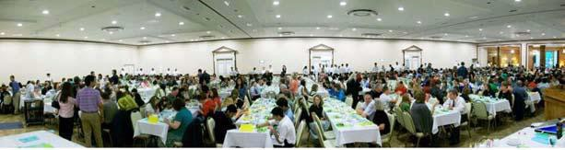

Annual IJAS banquet

Goals and Standards
As a result of participation in scientific investigation and the science exposition, students fulfill several national, state, and local goals and standards. The experiences of participation in authentic research inquiry and presentation at the IJAS Exposition aligns with the first dimension of the Next Generation Science Standards (NGSS), the College Readiness Standards (CRS), and the Common Core State Literacy in Science and Technical Subjects and Writing, and Writing for Literacy in Science and Technical Subjects: Research to Build and Present Knowledge. Please refer to the Appendix of this manual for alignment with the new standards.

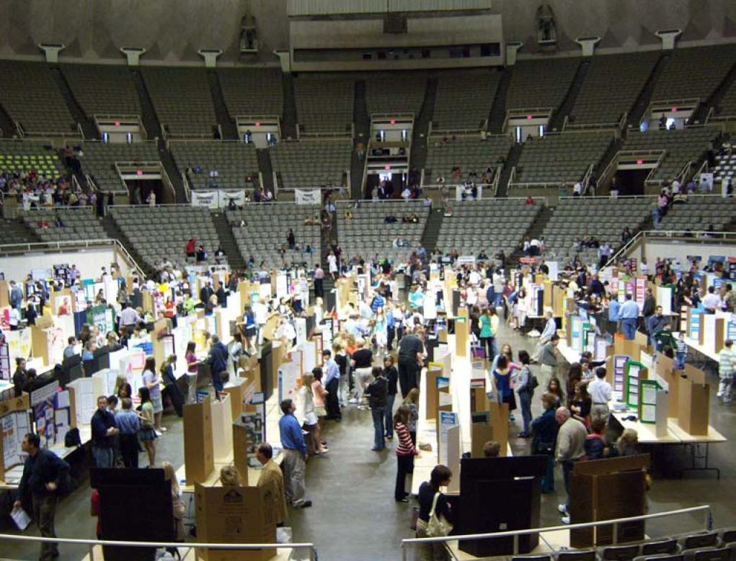

Poster Session at the State Science Exposition

The Science Project

Categories

Students must design an experiment to investigate a question or problem, or design or develop a new model, or computer program, or solve a mathematical proof, and so forth. A project based solely on library research is not an acceptable project. The following guidelines should give you an indication of what type of experimentation or project can be done within each category and should help to place a given project in the proper category for judging. Note that building without purposeful design and testing or demonstration is not an acceptable project.

Projects in any of the listed IJAS categories below may need an endorsement sheet(s), see pages 44-50. Please make sure that all safety rules are followed, and that all endorsements are completed and displayed.

A control group may not always be possible or necessary for all projects; a comparison among trials is appropriate and may be used instead.

Aerospace Science ... is the science of the study and investigation of the Earth's atmosphere and outer space. In the wide sense, it would include the design, manufacture, and operation of aircraft. Some topics that fall within this division are the operation of rockets, guided missiles, anything related to space travel, operation, and/or construction of satellites, observations of airflow patterns within tunnels, and the use of navigational equipment.

Astronomy... is the science dealing with all of the celestial bodies in the universe, including the planets and their satellites, comets and meteors, the stars, and interstellar matter, the star systems known as galaxies, and clusters of galaxies. Modern astronomy is divided into several branches: astrometry, the observational study of the position and motions of these bodies; celestial mechanics, the mathematical study of their chemical composition and physical condition from spectrum analysis and the laws of physics; and cosmology, the study of the universe as a whole.

Behavioral Science... is the science that studies the demeanor or deportment of humans and other animals by means of observable response and the interpretation of the same as offered by the social sciences, sociology, psychology, and so forth. Some topics that fall within this division are the effect of stimuli on organisms and their responses, learning, motivation, emotion, perception, thinking, individuality, personality, and adjustment.

Biochemistry... is the branch of chemistry relating to the processes and physical properties of living organisms. Topics that fall within the biochemistry division are the properties and reaction of carbohydrates, lipids, proteins, enzymes, blood, urine, vitamins, hormones, poisons, and drugs. The chemistry of absorption, digestion, metabolism, respiration, and photosynthesis as organic processes also belong in this category.

Botany... is the division of biology that deals with plant structure, reproduction, physiology, growth, classification, and disease. Some topics included in this category are specialization in plants, functions of various plant structures, reproduction, and heredity.

Cellular and Molecular Biology… is the study of the organization and functioning of the individual cell; molecular genetics focusing on the structure and function of genes at a molecular level. Other topics may include the structure and function of the immune system, innate and acquired immunity, and the interaction of antigens with antibodies. Molecular biology concerns itself with understanding the interactions between the various systems of a cell, including the interrelationships of DNA, RNA, and protein synthesis and learning how these interactions are regulated.

Chemistry... is the science that deals with the structure, composition, and properties of substances and of their transformations. Some topics included in this category are the composition of various compounds, the formulation of various compounds, the study of gas laws, atomic theory, ionization theory, and the analysis of organic and inorganic products.

Computer Science... includes the study and development of computer hardware, software engineering, Internet networking and communications, graphics (including human interface), simulations/virtual reality or computational science (including data structures, encryption, coding, and information theory). Topics in this category may include writing an original program and comparing it to an existing one, developing a new language and comparing it to an existing one, designing a network system, testing computer speed and efficiency, overclocking, and so forth.

Earth Science... is the science concerned with the origin, structure, composition and other physical features of the Earth. Some topics that fall within this division are geology (earth composition, rock formation, fossils, minerals, and fossil fuel); geography (landforms, soils, classification of streams, erosion, and sedimentation); oceanography (ocean waves, ocean currents, composition of ocean water and coastal zone management); seismology; geophysics; and meteorology.

Electronics... is the branch of engineering and technology that deals with the manufacture of devices such as radios, television sets, and computers that contain electron tubes, transistors, chips, or related components. Topics in this category are circuits (electrical, digital and analog) for communication such as radio, radar, laser, transistor, television, and integrated circuits; electricity; electric motors; solar cells and amplifiers.

Engineering... is concerned with the practical application of scientific knowledge in the design, construction, and operation of roads, bridges, harbors, buildings, and machinery, lighting, heating, and communication systems. Some topics in this category are stress testing of building materials, strength composition of building materials, collection of data from operating systems to compare and contrast their effectiveness.

Environmental Science... is the study of the protection and care of natural resources. Topics included in this category are solar energy and its uses, water purification and usage, pollution control, soil chemistry, and insecticides. Within this area is ecology, which is the study of ecological systems, and ecological population studies.

Health Science... is the study of the diseases/conditions and the health of humans, and/or the technologies associated with health. Topics to be found under this category may include anatomy, dentistry, pharmacology, physiology, pathology, ophthalmology, nutrition, sanitation, pediatrics, dermatology, neurology, allergies, speech and hearing, technical applications, and so on. May include studies using animals as models for human health studies.

Materials Science... is the study of materials, nonmetallic as well as metallic, and how they can be adapted fabricated and/or tested to meet the needs of modern technology. Using the laboratory techniques and research tools of physics, chemistry, and metallurgy, science is finding new ways of using plastics, ceramics, and other nonmetals in applications formerly reserved for metals.

Mathematics... is the science dealing with the measurement, properties, and relationships of quantities as expressed in numbers or symbols whether in the abstract or in their practical connections. Some topics included under mathematics are arithmetic (use of numbers, symbols, and numerical systems); algebra (probability, theory of equations, progressions, permutations and combinations); geometry (topology, study of geometric figures, similar figures, and scale drawings); calculus; trigonometry; statistics; and graphing.

Microbiology... is the branch of biology concerned with the study of microorganisms. Topics to be found in this category are the structure and physiology of bacteria, viruses, yeasts, fungi, and protozoa, and studies involving cells or tissues in cultures.

Physics... is the science that deals with the laws governing motion, matter, and energy under conditions susceptible to precise observation as distinct from chemistry or sciences dealing with living matter. Topics found in the category of physics are hydrostatic force and pressure, gravity, Newton's Laws, relativity, kinetic theory, motion forces, work, energy, sound, light, and magnetism.

Product/Consumer Science... is the study of comparisons and evaluations of manufactured or commercial products. Topics included in this category are taste tests, color preferences, quality control, and product efficiency.
Zoology... is the science that focuses on animals with reference to their structure, physiology, health, behavior, development, evolution, and classification. Some topics that fall within this category are structural and functional studies of vertebrates and invertebrates, reproduction, heredity, and embryology.

Choosing a Topic

- Be creative! Plan a project that is original in plan or execution. The project should express scientific ideas in new or better ways.

- Be scientific: investigate and explore an interest - a fascination - something that gives you a question you would like to be able to answer. The library and the Internet are excellent places to start.

- The student should consider the research problem in relation to his or her scientific background, financial situation, desire to contribute to science, the time required for the study, and the availability of resources and materials.

- It is important that each project have a central theme or purpose, that is, to answer a definite scientific question or to solve a problem.

- The experimentation and design behind an investigation is what is significant. A simple topic can offer a great challenge to the imaginative student.

- Start planning early in the school year.

- Be realistic about the time, cost, and available instrumentation.

Using the Scientific and Design Processes

Most projects will be experimental in nature using the scientific process and will fall into the experimental investigation classification. However, if the objective of your project is to invent a new device, procedure, computer program, or algorithm, then your project may fall into the design investigation classification.

Comparison of the Scientific Process vs. the Design Process

Scientific Process | Design Process
EXPERIMENTAL INVESTIGATION | DESIGN INVESTIGATION
- Identify and write a testable question. | - Define a need or real world problem.
- Perform background research. | - Perform background research.
- Formulate a hypothesis and identify variables  or comparison group(s). | - Establish design criteria.
- Design an experiment, establish procedure. | - Prepare preliminary design(s).
- Test the hypothesis by conducting the experiment. | - Construct and test a prototype
- Modify as needed and perform replicates.. | - Test and redesign as necessary
- Analyze the results and draw a conclusion(s). | - Analyze the design(s) and draw a conclusion(s).
- Present results. | - Present results.

Scientific Process for Experimental Classification

1. Identify and Write a Testable Question
Decide what question you want to answer or what problem you want to solve. A testable hypothesis is answered through observations or experiments that provide evidence. Be sure to have adequate technical and financial resources available to conduct your research. State your objective clearly in writing.

2. Perform Background Research
Before you begin your project, you must become as knowledgeable as you can about your topic and about other research that has been done on that topic. You may use books, scientific literature, the Internet, or interviews with scientists or other knowledgeable people. This research not only helps you get ready to conduct your experiment, but will form the basis for the Background Research paper (see pages 20-23) required in your report. Make sure that you document and cite all sources.

3. Formulate A Hypothesis
Based on the background research, write a statement that predicts the outcome of the experiment.
Many hypotheses are stated in an ―If . . . then statement where the ―if statement pertains to the independent variable, and the ―then statement pertains to the dependent variable. For example, if plants are grown under various colors of light, then the plants grown under blue and red lights will show the greatest increase in biomass.

4. Design The Experiment
Decide what data you need to meet your research objective and how you will collect it. Be sure to consider possible hazards in your experimental approach and decide how you can conduct your research safely (consult the safety section pages 14-19). In addition, IJAS has special rules concerning the use of human and non-human vertebrates in your research. Be sure to consult these rules (see pages 16-17) before finalizing your experimental design.

In order to obtain valid experimental results, consider the following items when designing the experiment:
- Make sure the quantity and quality of data you collect provides a reasonable assurance that your research objectives will be met.
- Identify all significant variables that could affect your results.
- Control any significant variables not manipulated in your experiment to the extent possible.
- Include a control or comparison group in your experimental design.

Be sure to establish deadlines for completing the different phases of your research. These phases might include building equipment, collecting data, analyzing the results, writing the report, and constructing your display board. Also, remember to use metric measurements whenever possible.

5. Conduct the Experiment, Modify as needed, and Perform Replicates
Follow your experimental design to collect data and make observations. Be sure to keep a notebook/log as you conduct the experiment to record your data, any problems you encounter, how you addressed them, and how these problems might have affected your data. This notebook/log will be used when you write your report.

6. Data, Data Analysis and Discussion, and Error Analysis
Keep these points in mind when conducting your experiment: If you get results that seem wrong or inconsistent, do not throw them out. Try to figure out what happened. Maybe the data is correct and your hypothesis is flawed. Try to explain these outliers. Don’t get discouraged when you encounter problems. Scientists often have to repeat experiments to get good, reproducible results. Sometimes you can learn more from a failure than you can from a success.

7. Analyze the results and draw conclusion(s)
Your report should provide all the information necessary for someone who is unfamiliar with your project to understand what you were trying to accomplish, how you did it, and whether you succeeded. It should be detailed enough to allow someone else to duplicate your experiment exactly. Be sure to include charts and graphs to summarize your data. The report should not only talk about your successful experimental attempts, but also the problems you encountered and how you solved them. Be sure to explain what new knowledge has been gained and how it leads to further questions.

8. Present the Results
For IJAS judging, you must also prepare an oral presentation (see page 24) and a display board (for poster session) (see page 25) to accompany the written report. Be sure to consult this policy manual, the section ―Writing A Research Paper, for IJAS report guidelines (see pages 20-23). These guidelines must be followed exactly.

Design Process for Design Classification

1. Define a Need or a Real World Problem
Instead of stating a question, state a need. Can you describe in detail a problem that your design will solve? Does your research relate to a real world need?

2. Perform Background Research
For a design project, the background research may include:
- A complete description of your target user(s)
- Information about the science behind your design area
- Answers to research questions about user needs
- Information about products that meet similar needs
- Research about design criteria
- What existing solutions are out there already, and how well do they solve the problem?
You may use books, scientific literature, the Internet, or interviews with scientists or other knowledgeable people. This research not only helps you get ready to conduct your experiment, but will form the basis for the Background Research paper (see pages 20-23) required in your report. Make sure that you document and cite all sources.

3. Establish Design Criteria - Provided as examples but not limited to:
Engineering Projects: Decide what features your design must have, for example: size, weight, cost, performance, power, and so forth. Include a table showing how each design criterion will be addressed by the features of the product being designed.
Computer Science Projects: Create or write a new algorithm to solve a problem or to improve on an existing algorithm. Discuss the criteria of the algorithm.
Mathematics Projects: Develop proofs, develop a new model or explanation, concept formation, or mathematical model design.

4. Prepare a Preliminary Design
Engineering projects should have a materials list, programming and mathematical projects do not need a materials list. Projects should include a block diagram, flowchart or sketch of the design that shows all of the parts or subsystems of the design. Describe how all of the parts of the design will work together.

5. Construct and Test a Prototype (Programs, algorithms, and mathematical models may be considered prototypes)
When others are conducting their experiment, investigators doing an engineering project, computer programming, or mathematics project should be constructing and testing a prototype of their best design. For example, you may involve targeted users in your testing to get feedback on your design; or some projects may analyze data sets.

6. Test and Redesign as Necessary
Evidence that changes in design were made to better meet the performance criteria established at the beginning of the project. Test results may be included in tables, if applicable. Data analysis/validation may also be a part of this step.

7. Analyze the Design and Draw Conclusion(s)
Your report should provide all the information necessary for someone who is unfamiliar with your project to understand what you were trying to accomplish, how you did it, and whether you succeeded. The report should not only discuss your successful design attempts, but also the problems you encountered and how you solved them. Be sure to explain what new knowledge has been gained and how it leads to further questions.

8. Present the Results
For IJAS judging, you must also prepare an oral presentation (see page 24) and a display board (for poster session) (see page 25) to accompany the written report. Be sure to consult this policy manual, section ―Writing a Research Paper - for IJAS report guidelines (see pages 20-23). These guidelines must be followed exactly.

Rules and Regulations

The student and the sponsor have ultimate responsibility for the safety of the student and test subjects while doing experiments or otherwise developing a project for a Science Exposition. Because many dangers may not be readily apparent, some guidelines are presented here to aid in developing a safer project.

All project development and experimentation must be conducted only with proper supervision. This is particularly true for chemicals, radiation sources, biological cultures, and so forth, many of which are governed by rules and regulations, both State and Federal, that affect both handling and disposal.

All exhibits must conform to the following regulations for region and State expositions. These same rules should be used, where applicable, at local as well as district expositions.

- Your school must currently be a member of the Illinois Junior Academy of Science, Inc.

- To participate at the State Exposition, you must have participated in a Regional Fair and have been selected for the State Exposition.

- No projects presented in previous years will be allowed at the Region or State Exposition unless they have been improved and expanded and are the result of further research and experimentation. Differences from previous projects should be clearly stated.

- The IJAS State Exposition is open to students in grades 7-12. Grades 7 & 8 make up the junior division, while the senior division are comprised of grades 9, 10, 11, & 12.

- No apparatus may be on top of, under, behind, in front of, alongside, or hanging off of the display table.

- Only a display board and computer may be on top of the table. The computer must be battery operated; no electricity will be supplied.

- A typed research paper plus a typed one-page abstract of the paper must be displayed with your project. The abstract is the first page of the research paper and serves as the cover sheet. (See Appendix page 43). At the State Exposition, you must have three copies of your complete research paper. This must include the typed abstract, hand signed safety sheet, and any necessary endorsements specific to your project. Copies of your research paper may be used for special judging and may not be returned. It is recommended that you retain the original copy of your research paper.

- A typed safety sheet signed by the student and his/her sponsor must be located behind the Abstract in the research paper. If no safety hazards exist, a statement to that effect must be made. (See Appendix page 44). Lack of a signed safety sheet will result in the project being disqualified. This sheet must specify all hazards and potential hazards in addition to the precautions taken by the experimenter.

- If your project involves humans, non-human vertebrates, vertebrate tissues, or microorganisms, the appropriate endorsement must follow the safety sheet in your research paper. (See Appendix pages 46-49). Lack of this endorsement will result in disqualification

- A copy of the abstract, safety sheet, and any applicable endorsement sheet must be displayed on the front of the exhibitor’s display board. These sheets may be reduced to a minimum of a half sheet of standard paper.

- Students are to remain with their projects during the official period of judging.

- Projects may involve more than one student, but not to exceed four students.

- A student may enter only one project.

- Normal wear and tear on the exhibit is to be expected during the time that the exhibit is open to the public. If valuable equipment is with display (such as a computer), it is your responsibility for its supervision

- Neither the Illinois Junior Academy of Science nor the sponsors assume any responsibility for loss or damage to such equipment, materials, or research paper.
Safety Guidelines for Experiment and Design Investigations

All questions or clarifications regarding these safety regulations will be made by sponsors (not students or parents) to the Regional Chair in writing, by email, a minimum of one week prior to beginning the investigation. These regulations are designed for the safety of the fair participants, test subjects, judges, and visitors. There will be no deviation from these regulations.

Safety Contact Flowchart

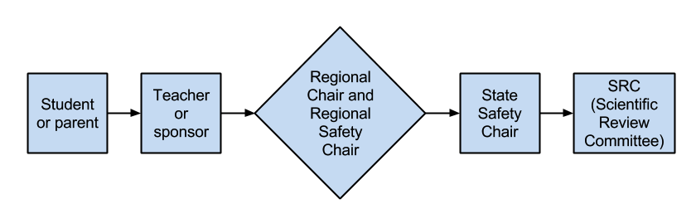

- Students should always wear eye protection and appropriate protective clothing when working on their investigation.

- Students should work under the supervision of a responsible adult.

Chemical Safety

- Before beginning a project, review the recommended procedures for safe use and handling of the chemical. The student and the sponsor should seek data from a textbook, Merck Index, Safety Data Sheet (SDS) or other responsible source regarding the health hazards, combustibility, and compatibility of the chemical with other chemicals.

- All chemicals must be disposed of in accordance with State and Federal Environmental Rules and Regulations.

- The Safety Sheet must include a statement as to the proper handling of any chemicals.

- Students who produce alcohol and distill in connection with a science fair project must follow the Safety Flowchart above prior to beginning the investigation.

Electrical and Mechanical Safety

- All electrical apparatus that operates with 115-volt current should be constructed in accordance with the National Electrical Code (NEC). If in doubt, contact a competent electrician.

- Many experiments can be done using a low amperage, 6 or 12-volt, electrical source. As these are much safer electrical sources, their use should be considered when doing a project.

- The Safety Sheet must include a statement as to proper electrical construction and an explanation of protective measures.

Fire and Radiation Safety

- Students using radiation sources (laser, U-V light, X-ray, microwaves, or high intensity radio waves) should be adequately shielded from such sources. Many experiments using these sources should not be undertaken unless under the direct supervision of an adult familiar with the equipment and hazards involved.

- No student may work with any radioactive materials unless the work is conducted in a licensed laboratory under the direct supervision of a licensed individual.

- Any student working with burning materials should perform the experiment under a fume or chemical hood or in an open air environment.

- The Safety Sheet must include an explanation of all protective measures.

Firearms and Explosive Safety

The provisions of this section shall not apply to model rocketry, provided any demonstration or experiment involving a model rocket is supervised by a parent, guardian or teacher over 21 years of age and all local, municipal, state and federal laws are strictly adhered to at all times concerning any model pocket, rocket engine or accessory.

No demonstrations or experiment using firearms or explosives can begin without prior approval from the Safety Review Committee. Make sure your Request for Use of Firearms letter is filed as soon as possible to allow enough time for the Safety Review Committee to review and process it. The letter MUST describe in detail the experimental procedure and the list the adult who will conduct the experiment as described below. Any advance permission issued shall be valid to conduct experiments or demonstrations for a period of thirty (30) days following approval, after which further experiments or demonstrations may not be conducted unless the advance permission is renewed or separate advance permission for a new or different demonstration or experiment is given.

- The student may not possess, handle or utilize any firearm at any time for conducting the demonstration or experiment for a science fair project; and the student and all bystanders, if present during the demonstration or experiment, must be behind a ballistic shield and wear eye and ear protection.

- The firearm must be handled at all times and the demonstration or experiment must be directly conducted at all times by a person over 21 years of age who is certified as a police officer by the Illinois Law Enforcement Training and Standards Board or by a person himself or herself licensed as a Private Detective or Private Security Contractor and in possession of a currently valid Firearms Control Card issued by the Illinois Department of Financial and Professional Regulation (“IDFPR”) (Note: a Concealed Carry License issued by the Illinois State Police SHALL NOT SUFFICE, and a Permanent Employee Record Card “PERC” issued by the IDFPR SHALL NOT SUFFICE).

- The police officer or IDFPR-licensed professional conducting and supervising the demonstration or experiment must provide a written statement describing the demonstration or experiment in detail, provide a copy of all of his or her credentials, and certify under the police officer’s or IDFPR-licensed professional’s signature that the demonstration or experiment is safe to all persons involved; and explain why and how the demonstration or experiment is safe to all persons involved. This letter must be attached to the Safety Sheet (see page 45).

- The police officer or IDFPR-licensed professional supervising the demonstration or experiment must provide a Certificate of Liability Insurance in the amount of no less than $1,000,000.00 naming the Illinois Junior Academy of Science, Inc., as “ADDITIONAL INSURED”; the facility where the demonstration or experimentation will be conducted must be recognized by the Illinois State Police and will be required to provide a Certificate of Liability Insurance in the amount of $1,000,000.00 naming the Illinois Junior Academy of Science, Inc., as ‘’ADDITIONAL INSURED”.

- The student, parent, guardian, police or professional supervisor, and all persons present during the conduct of the demonstration or experiment must provide a release of liability for the benefit of, and in a form agreeable to, the Illinois Junior Academy of Science, Inc., such form shall be provided when the student is granted permission to conduct the demonstration or experiment.

- The demonstration or experiment must not involve the hand loading or reloading of ammunition and may not utilize any black powder or muzzle loading gun.

- Any demonstration or experiment involving a firearm must utilize at all times commercially-loaded fixed cartridge ammunition manufactured according to SAAMI standards.

- The firearm utilized must be commercially-manufactured and may not be older than fifty (50) years of age.

- The demonstration or experiment shall not involve making or testing modifications or alterations to the firearm itself.

- All local, municipal, state and federal laws and regulations must be strictly adhered to at all times.

- No firearms or ammunition can be present at any level of science fair (school/district science fair, Regional Fair, State Fair and ISEF).

Drone Safety

- Drones may be used in a science project provided the use complies with all Federal, State and community rules, regulations and ordinances. In addition, the use of a drone for a science project may not infringe on anyone’s privacy or air space.

Biological Safety

Use and Care of Humans as Test Subjects

Recognizing that human beings are animals needing different criteria, the following policies will govern the use of human beings. No project will be allowed that is in violation of any of these rules.

No person may perform any experiment for the student that violates any of these rules. No person may give permission for a project that is in violation of these rules except in special cases as described in the section "Special Circumstances/Exceptions” (see page 18).

If using humans as test subjects, the following rules must be observed.

- Students who have a project involving human test subjects must complete, with their sponsor, the Humans as Test Subjects Endorsement form (see Appendix- page 45) that is included in this policy manual. Feel free to duplicate as needed.

- Humans must not be subjected to treatments that are considered hazardous and/or that could result in undue stress, injury, or death to the subject. To avoid potential disqualification, contact the Regional Safety Chair prior to experimentation if you are uncertain that the treatment may cause undue stress, injury, or harm.

- No primary or secondary cultures (the growth of microorganisms, tissue cells, or other living matter in a specially prepared nutrient medium) taken directly (mouth, throat, skin, and so forth) or indirectly (eating utensils, countertops, doorknobs, toilets, and so forth) will be allowed. However, cultures obtained from reputable biological suppliers or research facilities are suitable for student use (see Microorganisms section, pages 17-18).

- Quantities of food and non-alcoholic beverages are limited to normal serving amounts or less and must be consumed in a reasonable amount of time. Normal serving amounts must be substantiated with reliable documentation, such as a food label. This documentation must be attached to the Humans as Test Subjects Endorsement form. No project may use over-the-counter drugs, prescription drugs, illegal drugs, or alcohol in order to measure their effect on a person.

- Only human blood and/or other bodily fluids (urine, saliva, tears, cerebrospinal fluid, etc.) may be used are those samples/specimens, which are either purchased or obtained from a blood bank, hospital, or laboratory. No blood may be drawn or other fluids collected from any person specifically for a science project. This rule does not preclude a student making use of data collected from tests run on blood or other fluids that were collected for a purpose other than exclusively for a science project.

- Any project involving human teeth must have the teeth sterilized prior to experimentation.

- Projects that involve exercise or physical activity and its effect on pulse, respiration rate, blood pressure, and so on are allowed provided the exercise is not carried to the extreme. Electrical stimulation is not permitted. A valid, normal physical examination must be on file for each test subject. A letter from authorized school personnel, such as a school nurse, stating that all of the participating students have a physical examination on file indicating that they are physically able to participate, must be attached to the Humans as Test Subjects Endorsement form. (See Appendix page 46).

- Projects that involve learning, ESP, motivation, hearing, vision, and surveys require the Humans as Test Subjects form. (See Appendix page 46).

Use and Care of Non-Human Vertebrates

The basic aim of experiments involving animals is to achieve an understanding of life processes and to further society's knowledge. Experiments requiring the use of vertebrates must have a clearly defined objective, investigate a biological principle, and/or answer a scientific inquiry. Such experiments must be conducted with a respect for life and an appreciation of humane considerations.

To the degree possible, all students should be cautioned about doing projects that involve vertebrates. However, if the teacher and the student feel that vertebrates must be used, the following rules must and will apply. This policy will place the Illinois Junior Academy of Science in close accord with the "School Code of the State of Illinois."

It is strongly recommended that living organisms such as plants, bacteria, fungi, protists, worms, snails, insects or other invertebrates be used. Their wide availability, simplicity of care, and subsequent disposal make them very suitable for student work.

No non-human vertebrate projects will be allowed that are in violation of any of these rules. No person may perform any experiment for the student that violates any of these rules. No person may give permission for a project that will be in violation of these rules except in special cases as described in the section "Special Circumstances/Exceptions" (see page 19).

- Students who have projects that involve non-human vertebrates must complete, with their sponsor, the Non-Human Vertebrate Endorsement form (see Appendix page 47) that is included in this policy manual. Feel free to duplicate as needed.

- The student and the sponsor have the responsibility to see that all animals have proper care in well- ventilated, properly lighted locations with proper nutrition, proper temperature, adequate water, and sanitary surroundings. Care must be taken to see that the organisms are properly cared for during weekends and vacation periods.

- No primary or secondary cultures (the growth of microorganisms, tissue cells, or other living matter in a specially prepared nutrient medium) involving warm-blooded animals taken directly (mouth, throat, skin, etc.) or indirectly (cage debris, droppings, countertops, and so forth.) will be allowed. However, cultures purchased from reputable biological supply houses or research facilities are suitable for student use. (See Microorganisms section, pages 18).

- No intrusive or pain-producing techniques may be used. These prohibited techniques include, but are not limited to, surgery, injections, taking of blood, burning, electrical stimulation, or giving of over-the-counter drugs, prescription drugs, illegal drugs, or alcohol to measure their effect.

- No changes may be made in an organism’s environment that could result in undue stress, an injury, or death to the animal without prior approval (See Special Circumstances/Exceptions on page 19).

- No vertebrates can be used as the independent or dependent variables in an experiment that could result in undue stress, an injury, or death to the animal.

- For maze running and other learning or conditioning activities, food or water cannot be withheld for more than 24 hours. If the animal has a high metabolic rate, then food or water cannot be withheld for a length of time that would produce undue stress on the animal.

- Chicken or other bird embryo projects are allowed, but the treatment must be discontinued at or before 72 hours before scheduled hatch day. At that time, the egg must be destroyed.

- Projects that involve behavioral studies of newly hatched chickens or other birds will be allowed if no changes have been made in the normal incubation and hatching of the organism, and that all vertebrate rules are followed. (Only non-manipulated eggs may be hatched).

Use and Care of Microorganisms

No microorganism projects will be allowed that are in violation of any of these rules. No person may perform any experiment for the student that violates any of these rules. No person may give permission for a project that will be in violation of these rules except in special cases as described in the section "Special Circumstances/Exceptions". (See page 19).

- Students who have a project involving microorganisms must complete, with their sponsor, the Microorganisms Endorsement form. (See Appendix page 49) that is included in this policy manual. Feel free to duplicate as needed.

- All microorganism experimentation must be conducted in a laboratory setting such as a science classroom or professional research facility. Experiments with microorganisms, except for Saccharomyces cerevisiae, (Baker’s yeast), may not be done at home.

- Any projects involving growth of mold or rotting of organic material must be done in science classroom or professional research facility.

- This area of science may involve many dangers and hazards while experimenting. It is the sole responsibility of all teacher(s)/sponsor(s) to teach students proper safety methods and aseptic techniques. Students should wear safety goggles, gloves and wash hands after each experiment.

- The Illinois Junior Academy of Science prohibits the use of primary or secondary cultures taken from humans or other warm-blooded animals in any project because of the danger from unknown viruses or other disease-causing agents that may be present. Pure cultures of microorganisms known to inhabit warm-blooded animals may be obtained from reputable suppliers and used in proper settings.

Culture: the growth of microorganisms, tissue cells, or other living matter in a specially prepared nutrient medium.
A primary culture is one taken from a vertebrate animal, living or dead. For example, a culture may not be taken from a mouth, throat, skin, hamburger, meat, chicken, or fish.
A secondary culture is a culture taken from an object that has come in contact with a vertebrate animal. For example, a culture may not be taken from eating utensils, doorknobs, toilets, countertops, milk, eggs, and so forth.

- Projects involving viruses and recombinant DNA projects should be done with the help of a professional and should comply with the National Institutes of Health (NIH) Guidelines unless the project is limited to a kit obtained from a legitimate supply house.

- All cultures must be destroyed by methods such as autoclaving or with a suitable NaOCl (bleach) solution before disposal.

- For information on “Microorganisms for Education”, visit: www.science-projects.com/safemicrobes.htm

Safety Questions and/or Clarifications

Please see the IJAS web site for contact information for the IJAS Safety Chair: www.ijas.org.

Special Circumstances/Exceptions

Exceptions to the rules will be granted only in two circumstances:

1. The student performs the experiments and is supervised in a university lab, a research facility, or other professional facility. In these circumstances, the student must have a letter on the organization/research facility’s letterhead from the supervisor stating that the student worked under constant supervision and that all rules and regulations were followed.
- This original letter must directly follow the required endorsement form in the student’s original written paper.
- A copy of this letter must be displayed on the front of the display board with the other endorsement sheets.

2. If the student will not be supervised in a professional research institute, approval for any exceptions to the rules will be granted only if the following conditions are met:
- The sponsor must seek approval for the project before experimentation begins and/or as needed.
- The student (under the supervision of the sponsor) must prepare a detailed proposal of the project that includes the hypothesis, the proposed methods of experimentation, and must be able to demonstrate that safety measures will be taken that reflects professional protocols.
- The proposal is submitted to the IJAS Scientific Review Committee (SRC) Please see the IJAS website. For contact information: www.ijas.org.
- If the proposal receives approval, the project may be entered into the State Exposition if it qualifies at the Region. A written reply to the sponsor regarding the decision will be made no later than two weeks following receipt of the request.
- A copy of the approval letter is displayed on the front of the display board with the other endorsements.
- The approval letter is inserted into the student’s written paper directly following the appropriate endorsement.

~Communication~

Science Exposition is the time for communication. You are being judged on your ability to present your research as a researcher. The Written Communication and the Oral Presentation components are common to both Poster and Paper Sessions.

Written Communication

Writing a Research Paper for a Science Investigation

Scientists, regardless of their level of achievement, are only as effective as their ability to communicate to others, in spoken or written word, the results of their endeavors. A scientific paper is, very simply, a clearly written, concise report of an experimental research project. Four copies of the paper are required for Poster Session and two copies of the paper are required for Paper Session.

References and embedded citations follow APA format; however, charts, graphs , tables, etc. do not have to follow APA format.

Technical Points of a Research Paper

In preparing the paper, the author should be concerned with the following mechanics:

- The paper must be typed, doubled spaced and have at least one-inch margins on standard 8 ½” X 11” paper.
- Printed pages may be double-sided.
- The font style and size must be appropriate for a scientific paper: sans serif font, for example 12 pt, Times New Roman.
- Correct grammar and spelling are evident.
- The paper must be neat and legible.
- The primary scientist’s last name is in the upper right-hand corner of all pages after the Table of
Contents.
- Graphs should be suitably titled and have all axes correctly labeled. Do not forget to include the correct units of measurement for any numbers.
- Photographs should be of good quality and contrast, and should have captions typed under them.

Desired Qualities of Scientific Writing

The following points should help you to write your paper in an acceptable scientific style:

- When writing the first draft, do not start until you have clearly thought out your paper; the desired final result should be a clear and understandable paper.
- Learn to use the technical words that save space or that convey meaning better than common words; by all means avoid the use of vague terms.
- Scientific writing is concise and objective.
- Voice should be consistent throughout the paper. (Historically, scientific writing has been passive voice, which avoids the use of I or We. However, this has changed in past years. Either passive voice or first person voice is acceptable, but voice must be consistent.)
- After you have written your first draft, reread, revise, and rewrite it. Your paper must be an accurate report of what you have done - check and recheck your calculations, references, spelling, and grammar.
- After you have finished the paper, have someone who is not familiar with the work read it over to make sure it makes sense.

The Physical Arrangement of the Written Report of the Experimental Investigation

The following section establishes the basic written report requirements. Familiarity with the basic techniques and requirements will help you to read and understand scientific publications, give you an inside view of how scientists think, and help you to write your own scientific paper that describes that the results of your research investigation. The main point to keep in mind is to think before you write, then rethink, revise, rewrite, and reread again and again. Make it clear and concise.

The paper must include (in this order):
1) Abstract - In preparing your abstract, you must keep in mind that:
- The abstract is a concise summary of your work.
- As the first sheet of your research paper, it will help the reader form an opinion of your work.
- You will find writing and rewriting will help you produce a good short summary of your project in the required form.
- The physical form of the abstract is as follows:
    - Typed single-spaced
    - Limited to about 200 words or fewer
    - Limited to three paragraphs - purpose, procedure, conclusion.
- Use the abstract form in the appendix (only the front side of the form should be used).
2) Safety Sheet - All safety hazards and precautions must be identified. If no safety hazards exist, a statement to that effect must be made. Use the form found in the Appendix (see page 45).
3) Endorsements - When human or non-human vertebrates, microorganisms and/or tissue cultures are used, endorsement sheets are required. Forms are found in the Appendix on pages 46-49.. IJAS SRC approval letter and/or endorsement letter from a professional on institutional letterhead should follow IJAS endorsement forms, if required.
4) Title Page - Your title should be concise and clear.
5) Table of Contents - Include subsection name and page numbers.
6) Acknowledgments – You should give credit to those who have helped you in your investigations for guidance, materials, and/or use of facilities.
7) Purpose and Hypothesis – You should state precisely the question you are attempting to investigate.
Include your hypothesis or the expected outcome of your testable question.
8) Background Research – You should report to the reader background information and/or work done in the past that pertains to your investigation. These references should be properly documented and listed in the section "Reference List." Traditional footnotes are not to be used for citing references. The correct citation style to use is discussed in detail in the Publication Manual of the American Psychological Association.
9) Materials and Methods – This should be a simple step-by-step account of what was done. The explanation of what was done must be clear and detailed enough so that the reader can duplicate the work.
The apparatus and materials used should be listed. Explain the workings of any apparatus you constructed
or used. Drawings, diagrams that are clearly labeled, and photographs are appropriate if they enhance and clarify your explanation. Do not use them as filler.
10) Results and Discussion –
Data
- Data are to be organized in tables and/or figures with graphic presentations that are easily read by someone not familiar with the work. All data should be listed, when possible. Summary data should follow the raw data.
- Choosing the appropriate type of graph is important. Graphs should be presented so that someone not familiar with the work easily reads them. Axes should be labeled with titles and correct units of measurement in metric when appropriate.
- If quantitative data are not involved, a day-by-day log may be used in place of tables and charts. In either case, care should be taken to ensure accuracy and clarity.
Data Analysis and Discussion
- The results section should include text that refers to the figures and tables; figures and tables on their own do not constitute the results section.
- Discussion should include your evaluation and interpretation of the data and/or results of your investigation, and compare your data to what others have found.
Error Analysis
    - Experimental and/or measurement error affecting the conclusion has been considered and discussed.
    - Ways in which error was/could have been avoided may also be addressed.
11) Conclusion – This should be a concise evaluation and interpretation of the data and/or results. The conclusion should be limited to the results of the investigation and should refer to the stated purpose and hypothesis.
12) Reference List - This is a list of published articles, books, and other communications actually cited in the paper. Sources should be current. The reference list section is arranged alphabetically according to the author/editor's last name when it is known or the first significant word in the title if the author/editor is not known. The correct style to use for citing references in the reference list section is discussed in detail in the Publication Manual of the American Psychological Association.

The Physical Arrangement of the Written Report of the Design Investigation

The following section establishes the basic written report requirements. Familiarity with the basic techniques and requirements will help you to read and understand scientific publications, give you an inside view of how scientists think, and help you to write your own scientific paper that describes that the results of your research investigation. The main point to keep in mind is to think before you write, then rethink, revise, rewrite, and reread again and again. Make it clear and concise.

The paper must include (in this order):
1) Abstract - In preparing your abstract, you must keep in mind that:
- The abstract is a concise summary of your work.
- As the first sheet of your research paper, it will help the reader form an opinion of your work.
- You will find writing and rewriting will help you produce a good short summary of your project in the required form.
- The physical form of the abstract is as follows:
    - Typed single-spaced
    - Limited to about 200 words or fewer.
    - Limited to three paragraphs - purpose, procedure, conclusion
- Use the abstract form in the appendix (only the front side of the form should be used).
2) Safety Sheet - All safety hazards and precautions must be identified. If no safety hazards exist, a statement to that effect must be made. Use the form found in the Appendix. (See page 45).
3) Endorsements - When human or non-human vertebrates or microorganisms are used, endorsement sheets are required. Forms are found in the Appendix on pages 46-49. IJAS SRC approval letter and/or endorsement letter from a professional on institutional letterhead should follow IJAS endorsement forms, if required.
4) Title Page - Your title should be concise and clear.
5) Table of Contents - Include subsection name and page numbers.
6) Acknowledgments – You should give credit to those who have helped you in your investigations for guidance, materials, and/or use of facilities.
7) Problem or Need – Precisely state the question you are attempting to investigate. Include your hypothesis or the expected outcome of your testable question.
8) Background Research – You should report to the reader background information and/or work done in the past that pertains to your investigation. These references should be properly documented and listed in the section "Reference List." Traditional footnotes are not to be used for citing references. The correct citation style to use is discussed in detail in the Publication Manual of the American Psychological Association.
9) Design Plan – This should be a simple step-by-step account of what was done. The explanation of what was done must be clear and detailed enough so that the reader can duplicate the work. The apparatus and materials used should be listed. Explain the workings of any apparatus that was constructed or used. Drawings, diagrams that are clearly labeled, and photographs are appropriate if they enhance and clarify your explanation. Do not use them as filler.

10) Results and Discussion
- Constructing and Testing the Design Prototype – a description of the prototype/computer program/mathematical algorithm has been included. The prototype has been tested and the results have been discussed. . This may involve targeted users and/or analysis of data sets. (This may or may not include traditional data such as tables and graphs.
- Results of Testing and Redesign - Testing results have considered the parts and subsystems that required redesign in order to meet the performance criteria, and the redesign shows the changes in parts and subsystems.
- Redesign and Retest - Shows evidence that changes in design were made to better meet the performance criteria established at the beginning of the project. Test results may be included in tables, if applicable. Data analysis/validation may be present.
11) Conclusion – This should be a concise evaluation and interpretation of the data and/or results. The conclusion should be limited to the results of the investigation and should refer to the stated purpose and hypothesis.
12) Reference List - This is a list of published articles, books, and other communications actually cited in the paper. Sources should be current. The reference list section is arranged alphabetically according to the author/editor's last name when it is known or the first significant word in the title if the author/editor is not known. The correct style to use for citing references in the reference list section is discussed in detail in the Publication Manual of the American Psychological Association.

Oral Presentation

In presenting your investigation to the judges at a science exposition, the following approaches have proven successful for many students. Time should be limited to 15 minutes: 10-12 minutes for presentation, leaving 3-5 minutes for questions and discussion. PLEASE, PUT AWAY YOUR CELL PHONE!

1) Introduction
- State your name(s), age, school.
2) Acknowledgments
- Give credit to those whom you have contacted and to those who have helped you.
- Discuss any work done in the past pertaining to your project.
3) Purpose, Hypothesis, Need
- State exactly what the investigation is attempting to discover or the need it addresses.
- Make a prediction about the outcome.
- How did you get interested in this project? Give the reason for choosing it.
4) Background Information
- Background explanation for your project (to familiarize the judges), scope of your study, and so forth.
- This should include a summary of the Background Research.
5) Procedure/Design Process
- Summarize the experimental procedure and/or design process.
- Use visual aids: charts, pictures, graphs, and so forth. Point to your display, but stand aside when you do this.
- Explain how your apparatus was used. If you constructed it yourself, tell the judges you did, if not, give credit to those who helped you. Judges are more interested in your results and conclusions than in the apparatus, unless you have a design project.
- Discuss ways you avoided experimental error such as use of appropriate instrumentation and measurements, large enough sample size, and/or having controls when possible.
6) Results (Data and Conclusion)
- Explain both your controls and your experimental variables or prototype(s).
- Remember to use proper units of measure with your data.
- Point to tables, figures, and so forth when you refer to them.
- Analyze and discuss statistical aspects of experimental errors such as averages, ranges, and/or other statistical analogies.
- State in a concise and logical order the conclusions you can validly draw from the experimentation you have done and the data and/or observations obtained.
7) Discussion
- Discuss how you plan to continue your project, if applicable.
- Be sure to explain what knew knowledge has been gained and how it leads to further questions.
- Discuss how your work, positively or negatively, relates to what others have done.
8) Any Questions
- When you have finished, ask the judges if there are any questions they would like to ask.
- When they ask you questions, think before you answer them. Answer slowly! If you don't know the answer say, ''I'm not sure but I think ...”
- If they ask you a question that is not related to your project and you do not know the answer, then say, ''I really haven't been concerned with this in my project, but it might be interesting to look into it.''
- Thank the judges for any suggestions they may have for improving your research.
9) Other Suggestions
- Speak slowly!
- Be forward but polite, dynamic, and above all interested in what you are doing.
- Remember that you are a salesperson and therefore your job is to sell your product to the judges. The judges are interested in your work - which is why they are judging you.
- Your presentation should not exceed 10-12 minutes, and should allow an additional 3-5 minutes for questions.

~ The Exposition ~

Poster Session

Display Guidelines/Rules

This is neither the time nor place to demonstrate your experiment. No apparatus will be allowed to be displayed - display board and computer only. Pictures, drawings, diagrams and video footage of experiment should replace equipment. Computers may be used to enhance the presentation but media presentations, such as PowerPoint, Prezi or Google Slides, are not acceptable.

- Before judging, all of the displays will be carefully inspected by the safety committee at the regional and state expositions. A copy of the abstract, safety sheet(s), endorsement(s)/required document (if applicable), must be displayed on the front of the exhibitor’s display board. They may be reduced to a minimum of a half sheet/75% (5.5 inches X 8.5 inches) of standard paper and stacked.
- Your display must not exceed the dimensions of 61 cm (24”) front to back, 107 cm (40”) from side to side, and 152 cm (60”) from table to top. This applies to all parts of your project.
- No apparatus may be on top of, under, behind, in front of, alongside, or hanging off of the display table.
- Only a display board and computer may be on the table. The computer must be battery operated; no electricity will be supplied.
- Your display must be designed to sit on a table and be self-supporting.
- Material used for packing displays may not be kept within the display area, including under the table. It must be taken from the building.
- Table drapes or covers are not allowed.
- Spotlights, floodlights, or decorative lighting may not be used to illuminate your display.
- Any violation of these safety regulations will result in a letter to the sponsor with the reason for disqualification or potential disqualification. No project will be disqualified if the safety violation can be corrected on the spot with a minimum of effort.

Planning an Attractive Display

- The student should construct the display, with the parent, teacher, or sponsor providing guidance, encouragement, and constructive criticism.
- The title should be brief, captivating, and sufficiently descriptive to identify the project.
- Lettering should be neat, easily visible, and uncluttered. Check correctness of spelling.
- Displays should be neat and presentable.
- Do not display any previous awards on your project.
- Wall space for posters, tape, tacks, etc., is not available. Construct displays so that wall space is not required.
- Exhibitors should bring their own tape, thumbtacks, and other supplies.
- The abstract, safety sheet, and any endorsements must be placed on the front of the display board.
- .

Paper Session

The Following Set of Rules Applies Exclusively to Entering the Science Fair Paper Session

If you decide to enter your project in the Paper Session, write your paper following the guidelines given in the section entitled - Writing a Research Paper for a Science Investigation. Below are additional regulations and procedures for the Paper Session.

- Paper session projects and presentations may involve more than one student. All awards will be presented to the student whose name is first on the Abstract.
- The paper should be an accurate presentation of a project done by the student(s) and should reveal the experimentation and/or designs that have been made. Experimentation or design is required as explained in the Category section. A paper based solely on library research is not acceptable.
- Previously presented papers will not be allowed unless they include a significant amount of additional research and experimentation. These previously presented papers must be made available to the state Paper Session Chair if requested.
- A digital copy (pdf) of the complete paper including the Abstract, Safety Sheet, and endorsements if applicable must be submitted to the Regional Paper Session Chair by the date established at the regional level.
- The student should bring two copies of their complete paper to their presentation room on the day of the State Exposition. These copies MUST have original signatures on the Safety Sheet and Endorsement Sheets. Failure to present copies of the paper with original signatures may result in disqualification.
- The presentation may be read, given from notes, or be a computer presentation (preferred). Students may use programs such as PowerPoint, Prezi, or Google Slides to create their presentation. The complete presentation may take no longer than 10-12 minutes, with additional time (3-5 minutes) allowed for questions and answers.
- Display boards are not permitted; however tables, figures, and so forth may be presented manually, but may not exceed the dimensions of a standard 8.5” X 11” sheet of paper.
- Further research, conducted after the regional fair, may be presented as a written addendum given to the judges at the time of the oral presentation, but a revised paper may not be submitted to the exposition.
- State awards for Paper Session will be given at the Awards Assembly on the final day of the State Exposition.

Essay Contest

Student Officer Essay Contest

Purpose
The Illinois Junior Academy of Science Student Officer Essay Contest is sponsored by the Illinois Junior Academy of Science for the purpose of providing students the experiences of researching, writing, and presenting an essay in an area of current interest. This contest is judged by the State IJAS Student Board.

Definition
The essay entered should be based on library research and should not be experimental in nature.

Logistics
Essays should be submitted digitally to the essay chair, as detailed in the President’s mailings. Ten essays may be submitted per region; the deadline for submission is 48 hours after completion of the regional exposition. The top ten submissions will be selected and notified two weeks prior to the State Exposition or as detailed in the President’s mailings.

Structure
Write clearly and simply using correct spelling and grammar. The essay must include:
- An Essay Cover Page or facsimile as the first page of the essay (see Appendix page 50).
- A title that is descriptive of the content of the essay.
- A text that includes an introduction, body, and summary. Introductory material may be set up in one or more paragraphs. The summary should also include your general conclusions.
- A Reference List showing references used in APA style.

Rules
- The contest is open to students in Grades 7 through 12 enrolled in a school that is registered with the Illinois Junior Academy of Science
- All essays entered must have a single author.
- The essay should be 1200 to 1500 words and must be word-processed and double-spaced.
- The essay must include a cover page as the first page of the essay. The Essay Cover Page form is found in the appendix (see page 50).
- Ten minutes will be allowed for the presentation. It should be presented, not read to the judges. It may be given from notes. Presentation is a significant part of the paper rating.
- The authors of papers selected for presentation at the IJAS State Paper Session Exposition will be notified 2 weeks prior to the state fair.
- The current topic of the Student Officer Essay Contest will be announced at the State Exposition in May, again via the President's Fall and Winter Mailings, and is posted on the IJAS website. Fixed formatting issue here.

Judging Criteria
Since the topics may change, some specific criteria will be noted in the State President's Fall and Winter
Mailings and on the IJAS website at www.ijas.org.

Selection Process
- Essays are to be submitted to the Regional Paper Chair for presentation at the Regional Paper Session.
- Regional paper sessions will judge essay presentations to select up to ten entries to the State Student Officer Essay Contest.
- Regional essays qualifying for State will be judged by the Student Board, and as many as the top ten finalists will be invited to present their essay at the IJAS State Exposition.
- Students whose essays qualify for presentation at the IJAS State Exposition in May will receive information from the Student Essay Officer Chairperson and a complimentary banquet ticket.

Additional Essay Contests

Several other organizations may offer the opportunity for student research in particular fields. The presentation of awards takes place at the IJAS banquet on Friday evening of the essay presentation. These essays must also have an Essay Cover Page when submitted (see Appendix page 50).

- Additional essays and requirements will be announced in the fall and/or winter mailing and on the IJAS website.
- The Illinois Junior Academy of Science Board of Directors and/or the contest corporate sponsors will annually determine financial awards for these contests.

Artistic Design Contest

Rules of Procedure

- Any student in grades seven through twelve whose school is a member of the Illinois Junior Academy of Science is eligible to take part in the cover design contest.
- Students do not need to compete in local, regional, or state science expositions with a project, paper, or essay to be eligible.
- The entry date for designs will be listed in the President’s mailings.
- Use an 8.5”x11” sheet of white paper for each entry. The design must be in a portrait (vertical) orientation. Landscape (horizontal) orientation will not be accepted.
- Include the words “Illinois Junior Academy of Science” in your design. These words should be large enough to be seen on the original design.
- The design must be original, non-computer generated image/artwork. The words “Illinois Junior Academy of Science” must be included on the design, and these words may be computerized.
- The theme of the design contest changes each year. Check the president’s Fall mailing and the IJAS website for more information
- Keep the design simple.
- All submissions must be black ink on white paper. No color paper or pencil.
- The artwork should be signed with the student’s name.
- Include the following on the back of student’s entry:

Student’s Information
Student’s name
Home mailing address
Home or cell phone number
Email address

Sponsor’s Information
School name
Name
E-mail
Phone number
Region number (ask your sponsor)

The design committee will judge all entries. The top entries will be presented to the IJAS Student Officers, and final voting will take place. As many as the ten top entries of the top finalists will be displayed at the State Science Exposition, and the designers of the winning contest entries will receive monetary awards and one complimentary banquet ticket.

Judging Criteria for Posters and Papers – Experimental Investigation

The following are criteria for the Illinois Junior Academy of Science judging procedure. Judges who are not agents of the Illinois Junior Academy of Science may use other criteria for selection of their special awards. The decision of the judges is final.

- There are usually three scoring levels for each factor being examined during the judging procedure.
- Student experimenters should strive to achieve the top criteria listed below.

Evidence of Scientific Processing Skills

Science Processing Skills
- Exhibits a thorough understanding and the application of the scientific method. The student has acquired scientific skills.
Scientific Approach: Overall
- Has a well-defined problem and a clearly stated hypothesis. Uses a logical, orderly method for solving the problem. Problem was solved using scientific principles. Method was appropriate and effective.
Scientific Approach: Variables
- The independent (experimental) variable(s) have been thoroughly defined. Those significant variables not manipulated have been controlled.
Scientific Approach: Control/Comparison Group
- A control (known standard) was present OR when a control group is not possible or appropriate a comparison was made among trial groups.
Accuracy of Data and Observations
- An adequate sample size and/or sufficient repetitions were performed to gather enough data to reach a reliable conclusion. Data collected is numerical and metric, if applicable. Observations were carefully recorded and accurate.
Data Analysis and Discussion
- The data has been analyzed and its importance has been discussed. Logical inferences were made.
Experimental Error
- Measurement error affecting the conclusion has been considered and discussed.
Validity of Conclusion
- Conclusion is consistent with data and observations and is supported by the data collected.
- Conclusion referred to purpose and hypothesis.
Originality
- Demonstrates a novel approach and/or idea. Exhibits a creative approach to problem-solving.

Scientific Communication - Display
Information: Experimental
- Gives complete explanation of the project. Display includes graphics, charts, and/or pictures.
Artistic Qualities
- Display board is neat, organized, and appealing. No spelling errors are present.

Scientific Communication - Oral Presentation

Presentation Quality
- Clear presentation; concisely summarizes the project. Information is relevant and pertinent. Student exhibits a thorough understanding of their topic area.
Dynamics
- Speaks fluently with good eye contact; polite, dynamic, and interested in their project.
Written Report
The parts of the written report should be evaluated for their merits as further evidence of scientific processing skills.

Abstract
- Abstract present; contains a concise summary of the purpose, procedure, and conclusion in 250 words or less. The proper IJAS form was used.
Safety Sheet
- The safety sheet identifies all of the major safety hazards, precautions taken, and any endorsement sheets (if necessary), which describe the use of human or non-human vertebrates or microorganisms, and ensures the safe use of such organisms. The proper IJAS form was used.
Title Page/Table of Contents
- Title page is clear and concise. The table of contents is complete and includes pagination.
Acknowledgements
- Credit has been given to those who have helped with the project.
Purpose and Hypothesis
- The testable question (purpose) has been identified and a prediction has been made.
Background Research (BR)
- Background research is in-depth and the information is pertinent and supports the experiment. BR is adequately cited using APA format.
Materials
- All materials are listed and measurements are in metric, if applicable.
Procedure
- Procedure is complete and easily followed; all steps included. Measurements are in metric, if applicable.
Results
- Results (data) are organized in tables or graphs and can be easily read by someone not familiar with the work. Discussion or interpretation of data and effect of error should be included.
Conclusion
- A concise evaluation and interpretation of the data and/or results.
Reference List
- Quality, quantity and variety of sources are adequate for topic. Sources listed are cited within Background Research.
- Most sources are current.
Technical Aspects
- Good grammar and spelling are evident. The student’s last name is in the upper right-hand corner of all pages after the table of contents. Font size and type are appropriate.
Neat and Orderly
- Is neat and follows the Policy and Procedure Manual order as illustrated on left side of judging sheet.

Judging Criteria for Projects and Papers – Design Investigation

Evidence of Design Processing Skills

Design Processing Skills
- Exhibits a thorough understanding and the application of the design process. The student has acquired design skills.
Design Approach: Overall
- Has identified a need or real world problem. Uses a logical, orderly method for addressing the problem or need. Method was appropriate and effective.
Design Approach: Performance Criteria
- Clear performance criteria have been developed to address the features of the product, algorithm, proof, model, etc.
Design Approach: Preliminary Design Plan
- A clear plan had been presented using a block diagram, flowchart or sketch. The design plan shows all of the parts and/or subsystems of the design and how all parts of the design work together.
Constructing and Testing the Design Prototype
- Have constructed and tested a prototype of their best design. This may involve targeted users and/or analysis of data sets. (This may or may not include traditional data).
Redesign and Retest
- Shows evidence that changes in design were made to better meet the performance criteria established at the beginning of the project. Test results may be included in tables, if applicable. Data analysis/validation may be present.
Validity of Evaluation/Conclusion
- The conclusion accurately reports the successes and failures of the preliminary design, what changes were made, and how the redesign more closely met the performance criteria.
Originality
- Demonstrates a novel approach and/or idea. Exhibits a creative approach to design. Shows evidence that other designs were investigated that addressed the same need or real world problem.

Scientific Communication - Display

Information: Experimental
- Gives complete explanation of the project. Display includes graphics, charts, and/or pictures.
Artistic Qualities
- Display board is neat, organized, and appealing. No spelling errors are present.

Scientific Communication - Oral Presentation

Presentation Quality
- Clear presentation; concisely summarizes the project. Information is relevant and pertinent. Student exhibits a thorough understanding of their topic area.
Dynamics
- Speaks fluently with good eye contact; polite, dynamic, and interested in their project.

Written Report

The parts of the written report should be evaluated for their merits as further evidence of design processing skills.

Abstract
- Abstract present; contains a concise summary of the purpose, procedure, and conclusion in 250 words or less. The proper IJAS form was used.
Safety Sheet
- The safety sheet identifies all of the major safety hazards, precautions taken, and any endorsement sheets (if necessary), which describe the use of human or non-human vertebrates or microorganisms, and ensures the safe use of such organisms. The proper IJAS form was used.
Title Page/Table of Contents
- Title page is clear and concise. The table of contents is complete and includes pagination.
Acknowledgements
- Credit has been given to those who have helped with the project.
Problem or Need
- Described in detail a real world problem or need.
Background Research (BR)
- Background research is in-depth and the information is pertinent and supports the design. BR is adequately cited using APA format.
Design Plan
- Design plan is complete and easily followed; all of the parts and/or subsystems of the design are included.
Results of Testing and Redesign
- Testing results have considered the parts and subsystems that required redesign in order to meet the performance criteria, and the redesign shows the changes in parts and subsystems.
Evaluation/Conclusion
- A concise evaluation and interpretation of the design, redesign and testing were made as they are related to the performance criteria.
Reference List
- Quality, quantity and variety of sources are adequate for topic. Sources listed are cited within Background Research.
- Most sources are current.
Technical Aspects
- Good grammar and spelling are evident. The student’s last name is in the upper right-hand corner of all pages after the table of contents.
- Font size and type are appropriate.
Neat and Orderly
- Is neat and follows the Policy and Procedure Manual order as illustrated on left side of judging sheet.

Rating Criteria

When rating the project and paper, the judges should consider the following:

Gold Award - The following criteria may identify an outstanding project.
- A scientific approach to a specific problem is supported with relevant experimentation.
    - Approach indicates creativity.
    - Conclusions logically deduced from experimental data.
    - Clear concise research paper containing abstract in required form, safety sheet, and Endorsement Sheet(s) when appropriate.
- Students can speak knowledgeably on contents of paper and area of investigation.
- Good quality and quantity of background information is reflected in the Review of the Literature and Reference List.

Silver or Bronze Award
A silver or bronze award is given for a lesser degree of the above criteria; for example, insufficient reference list, lack of thoroughness in experimental technique or observation, or lack of knowledge of subject area.

Participation Certificate
A serious omission or mistake is present; for example, no proof of experimentation or no scientific approach is evident. Any model or demonstration will be issued a participation certificate. The judging chair will supply specific tips and pointers for a given category.

Judging Information for the Poster and Paper Sessions - Experimental and Design Investigation

An Overview

Judging is, without a doubt, one of the most important phases of any science exposition. Because of its extreme importance, all judges should carefully review the following.

- Expositions are not intended to be contests between students or schools. Each exhibitor is to be judged based on the rating criteria and not in comparison to another exhibitor.
- Even though many exhibits show a remarkable degree of scientific knowledge, all judges are asked to keep in mind that all of the exhibitors are junior or senior high school students, many of whom are experiencing their first taste of scientific evaluation by a distinguished critic.
- As a judge, use your own good judgment at all times. Be honest with yourself and the student. Keep in mind that only a small percentage of the students will ever actually go into scientific research; however, many of them will have a great deal to say about the future of science. Certainly, a valuable experience with science at this level might potentially reap valuable rewards later.
- The opportunity to discuss their project with interested adults acting as judges is a high point for most students. Be aware that most students have spent many months preparing for a judging period, which normally lasts fifteen minutes. Feel free to discuss any aspect of the student's work; they deeply appreciate all questions and comments.
- In order to participate as a judge, you must be beyond high school age.

Judging Mechanics - Information for Judges

- Be sure to report for final instructions promptly on the day of the Exposition. Allow yourself enough time to park your car, and to allow for traffic interference so that you will report on time. The Category Judging Chair will inform you about when and where to report.
- At the judges meeting, you will be informed of any last minute changes and/or special instructions concerning judging assignments.
- Each judging team is to be assigned about six projects or papers to judge. Again, each exhibitor is to be judged based on the rating criteria and not in comparison to other exhibitors or based on your personal preferences.
- The Regional and State Expositions are planned so that each judging team is allowed fifteen to thirty minutes for each project or paper.
- You may be asked to judge projects in both divisions: Junior, grades 7 and 8 and Senior, grades 9,10, 11, and 12. If so, remember to judge them based on individual merit, and please keep the age of the exhibitor in mind.
- Each project judged must have a final score so that the certificate of award can be made. Be certain that you are using the correct rubric when scoring the project. Do not show or discuss students’ scores with them. Information on specific guidelines and procedures concerning ratings will be supplied by and discussed with the judging chair.
- Be pleasant and interested. Do not use cell phones while judging.
- Please remember that you are working with tomorrow's scientists; their ''decision for science" may rest on the impression you give them.
- Students must be with their project or at their assigned paper session room at the time of judging. If the cannot be located within a reasonable period of time, then the project or paper is considered a No Show, and no rating is to be given.
- Many intangible factors are involved in judging. These can be evaluated only by talking with the student and cannot be estimated merely by looking at the physical aspects of the exhibit. Judges should keep in mind that a spectacular exhibit or one composed of costly equipment is not necessarily the best science project.
- Fill out and return the judges’ comment sheet to the student. Please indicate comments that would help the student improve. Comments might be positive or constructive, but they should not be sarcastic. Please make sure that your comments are clear and to the point. Do not indicate the award on this sheet.
- It is imperative that each judging team finish its judging responsibilities in the allotted time, and have its judging results turned into the Category Chair on time. Enough time must be available to prepare the awards by the Awards Chair. Please allot your time accordingly so that results are turned in when due.
- Be sure every project for which you are responsible has been judged. Return the scoring rubric immediately following the judging of each project. Do not hold all scoring rubrics until you are finished judging all projects.
- Judges must return all materials (except for abstracts) to the student. You may not keep any other portion of the student’s paper.

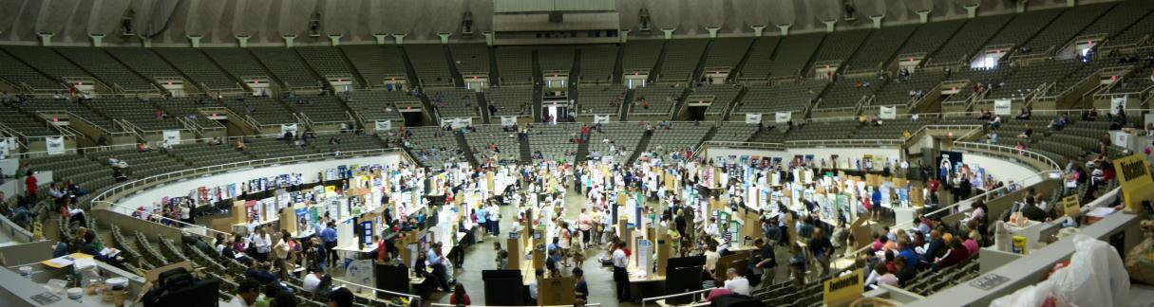

Information for Teachers, Sponsors, and Parents

Sponsors and Teachers

Behind the student is the sponsor, often a teacher of a science subject, but occasionally a dedicated citizen. These volunteers are the unsung heroes of the local, regional, and state expositions. The ways in which they can assist the students are:

- Instill interest within the students.
- Register in the fall with the State Illinois Junior Academy of Science (IJAS). Registration deadline is December 31. See Membership Form on the IJAS website for specific dates and details.
- Check with your region for specific regional fees and registration requirements; regional fees and registrations will vary.
- Provide materials that will help the student select the project: The Illinois Junior Academy of Science Policy and Procedure Manual, regional mailings, state mailings, and access to the IJAS website at www.ijas.org.
- Discuss how to develop a project, and show results of past projects.
- Review all rules, regulations, and safety policies and procedures. If students intend to carry out human or other vertebrate animal experimentation, make certain that they are aware of the procedures to follow and that they complete the proper endorsement forms (see Appendix pages 46-49).
- Participate in a local Science Exposition. This local exposition will give the students experience in the displaying and explaining of their projects and may determine which projects are worthy of Regional competition.
- Establish a deadline calendar. For example, project selection to be by the first week in October, progress reports by December, final sketches by January, and projects completed and ready for presentation by early February. This will leave time for final adjustments before the regional fairs.
- Consult your regional chair for deadline dates pertinent to your Region. Information can be found on the IJAS website at www.ijas.org.
- Arrange periodic small group discussions of progress on projects and provide an opportunity to analyze and solve problems related to individual projects.
- Offer encouragement and guidance.
- Ask others to assist, such as an English teacher for writing assistance, a mathematics teacher for assistance with statistics, or a science teacher with special expertise.
- Check the project and paper carefully to be sure the student has complied with all safety regulations and with the regulations for writing the paper and abstract before signing your name to the safety and/or endorsement sheets. As a sponsor, you are responsible for all aspects of the student’s project.
- Request the necessary entry materials for both the project and paper sessions. Since regional procedures may vary, consult with your regional chair for specific details.
- Provide qualified judges for both the Regional and State Expositions. Failure to comply with this requirement may result in the return of your project and/or paper entries. Judges must be aware of their responsibilities. If they cannot attend, they must provide a suitable replacement in the same judging area.
- Provide safety inspectors, runners, awards room workers, and other volunteers as required by the regional and/or state organizations.
- In all stages of competition, the judges’ decision is final.

Parents

We know that you are proud of the accomplishments of your son or daughter and that you are anxious to see them succeed in this introductory phase of a possible career or a lifelong interest in science. The role of the parent is to support their son or daughter’s independent efforts, not to take over the project. Your challenge is to provide just enough assistance to allow your son or daughter’s own efforts to take center stage, while offering ideas and resources that might help your child raise their efforts to a higher level.

Keep in mind the following suggestions:
- Review this Policy and Procedure Manual in its entirety and any other materials your son or daughter’s science teacher (sponsor) sends home about the requirements of the project. All State information is available on the IJAS website: www.ijas.org..
- Encourage your child as he or she brainstorms ideas for the project. Do not be too quick to shoot ideas down as impractical or expensive – let them explore ideas first. If you have concerns, form them into questions for your son or daughter to consider. If possible, allow him or her to rule out impractical ideas before you do.
- Make sure you understand what is required before approving a science project topic. Will it be able to be accomplished with all the other activities that your child is involved in, along with other academic requirements?
- Support your child in researching their topic and conducting the experiment; assist by supplying transportation (if needed), and access to information and materials. Often excellent learning opportunities will present themselves. You could teach your child to use a piece of equipment or machinery rather than doing it yourself just because it might be easier.
- Make sure you are familiar with the safety guidelines and see that they are followed. See pages 14-19. A student may be denied participation at the next level of exhibition if the project or paper is found to violate the established rules and regulations published in the most recent copy of the Policy and Procedure Manual of the Illinois Junior Academy of Science. Some projects will be disqualified if done at home.
- Assist your child in thinking through experimental or design procedures and how they plan to record and organize their data.
- Your child might need assistance in preparing their display board and presentation. Your role should be secondary to their efforts – things like reading through and suggesting editorial changes, helping with advanced computer applications, assisting with display board layout, and listening to their presentation.
- Special award judges, who are not agents of the Illinois Junior Academy of Science, may use other criteria for selecting their special awards. Not all projects will be judged for special awards.
- In general, show an interest in your son or daughter’s progress, offer support and encouragement, help them overcome problems, and praise their good efforts.
- If in doubt, contact your son or daughter’s science teacher or sponsor for assistance or encourage your child to do so.
- The Illinois Junior Academy of Science attempts to award and recognize as many students as possible. Proper handling of the successes and disappointments of a competition can lead to the continued efforts towards a higher goal.
- Celebrate the successes and spend a moment looking at what went wrong. Encourage a discussion as to how things might have been done differently. This process is an important part of both learning and science.
- In all stages of competition, the judges’ decision is final.

Appendix

Student Project Checklist | 38
Student Safety Checklist | 39
APA Style Resource Websites | 40
Next Generation Science Standards (NGSS) | 41
College Readiness Standards (CRS) | 42
Common Core State Standards (CCSS) | 43
Official Forms and Endorsement Sheets | 44-50
Abstract Form | 44
Safety Sheet | 45
Humans as Test Subjects Endorsement | 46
Non-Human Vertebrate Endorsement | 47
Tissue Culture Endorsement | 48
Microorganism Endorsement | 49
Essay Cover Sheet | 50

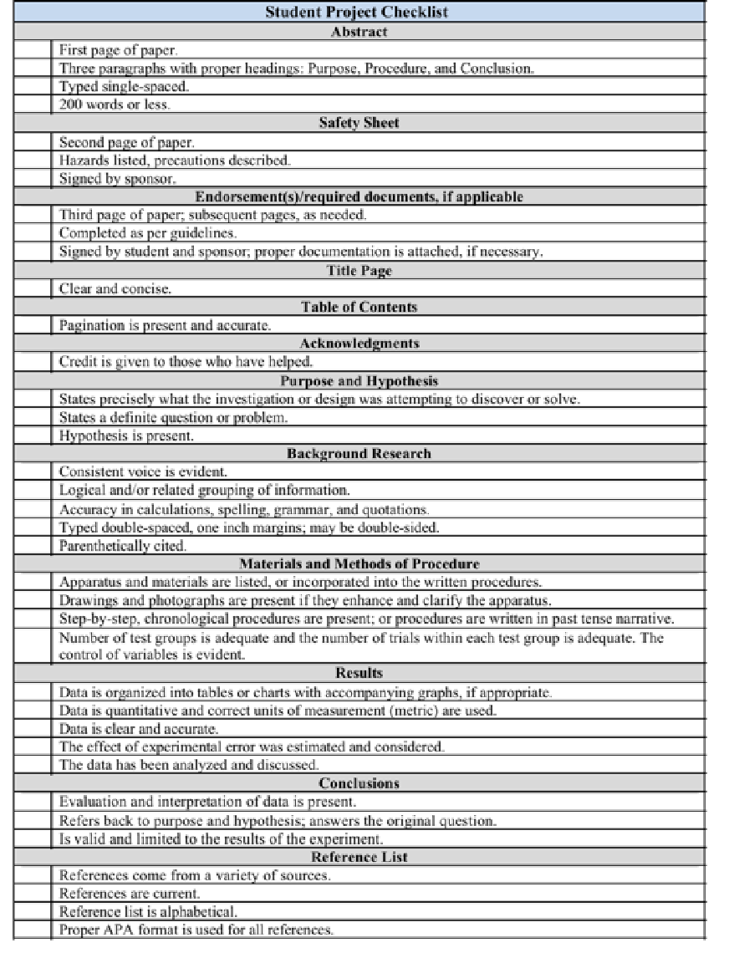

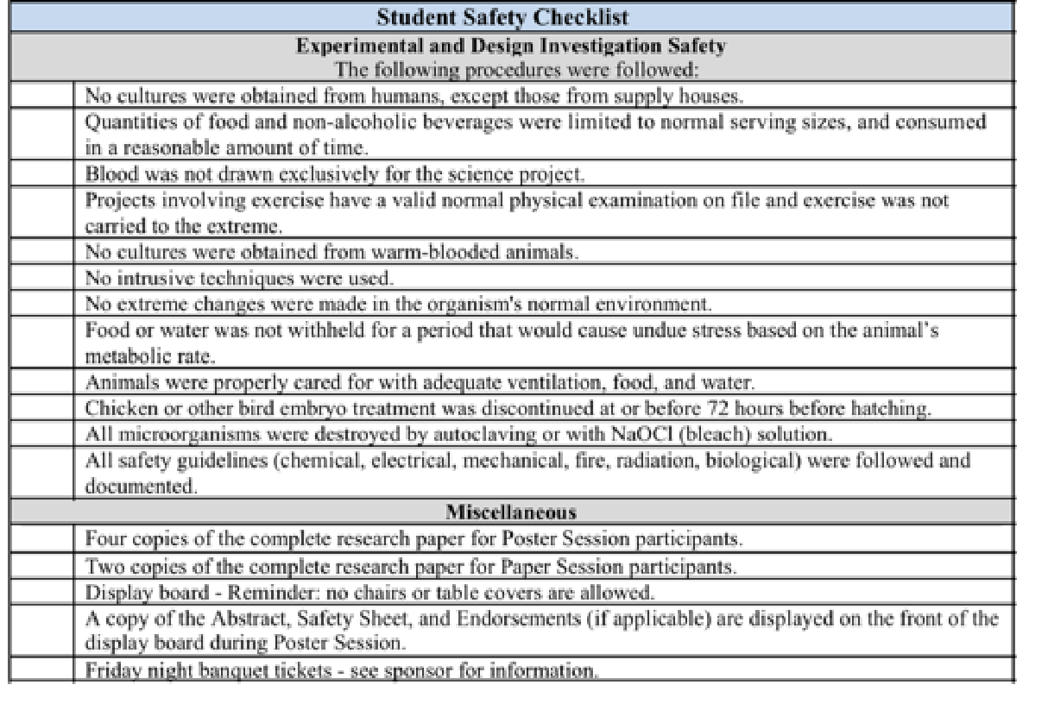

APA Style Resource Websites

These websites will introduce you to APA documentation, step-by-step instructions, format, citations, and reference lists. However, it is suggested you reference the Publication Manual of the American Psychological Association.
http://www.apastyle.org/ http://www.easybib.com

http://www.stylewizard.com http://www.noodletools.com http://www.citationmachine.net
Son of Citation MachineTM
http://citationmachine.net/index2.php

http://www.wisc.edu/writing/Handbook/DocAPA.html

University of Illinois Writers’ Workshop
http://www.cws.illinois.edu/workshop/writers/citation/apa/index.html

Online Writing Lab (OWL) at Purdue University http://owl.english.purdue.edu/

Zotero http://www.zotero.org/

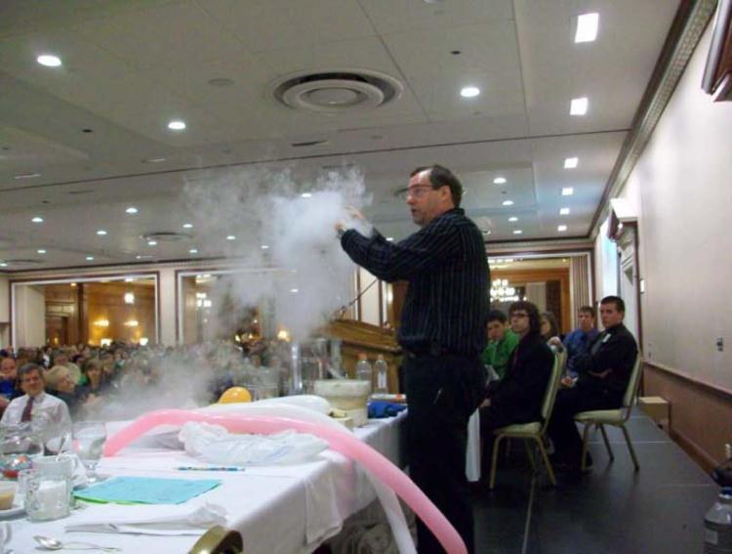
Mr. Freeze at the IJAS banquet.
The experiences of participation in authentic research inquiry and presentation at the IJAS Exposition aligns with the first dimension of the Next Generation Science Standards (NGSS), the College Readiness Standards (CRS), and the Common Core State Literacy in Science and Technical Subjects and Writing, and Writing for Literacy in Science and Technical Subjects: Research to Build and Present Knowledge.

Next Generation Science Standards
As students progress through a research investigation they will engage in the first dimension of the NGSS, which involve the processes of science. This dimension relates to the behaviors that scientists engage in as they investigate and build models and theories about the natural world and the key set of engineering practices that engineers use as they design and build models and systems.
1. Asking Questions and Defining Problems
1a. Ask and evaluate questions that challenge the premise of an argument, the
interpretation of a data set, or the suitability of a design.
2. Developing and Using Models
2a. Develop a model based on evidence to illustrate the relationships between systems or
between components of a system.
3. Planning and Carrying Out Investigations
3a. Design an investigation individually and collaboratively and test designs as part
of building and revising models, supporting explanations for phenomena, or testing solutions to problems. Consider possible confounding variables or effects and
evaluate the investigation’s design to ensure variables are controlled.
3b. Design and conduct an investigation individually and collaboratively, and in the design: decide on types, how much, and accuracy of data needed to produce reliable measurements and consider limitations on the precision of the data (e.g.,
number of trials, cost, risk, time), and refine the design accordingly.
3c. Design and conduct investigations and test design solutions in a safe and ethical manner including considerations of environmental, social, and personal impacts.
4. Analyzing and Interpreting Data
4a. Use tools, technologies, and/or models (e.g., computational, mathematical) to
generate and analyze data in order to make valid and reliable scientific claims or determine an optimal design solution.
4b. Evaluate the impact of new data on a working explanation of a proposed process
or system.
5. Using Mathematics and Computational Thinking
5a. Use mathematical representations of phenomena to describe explanations.
6. Constructing Explanations and Designing Solutions
6a. Make quantitative and qualitative claims regarding the relationship between
dependent and independent variables.
6b. Apply scientific reasoning, theory, and models to link evidence to claims to assess the extent to which the reasoning and data support the explanation or
conclusion.
7. Engaging in Argument from Evidence
7a. Evaluate the claims, evidence, and reasoning behind currently accepted explanations or
solutions to determine the merits of arguments.
7b. Evaluate the evidence behind currently accepted explanations to determine the merits of
arguments.
8. Obtaining, Evaluating, and Communicating Information
8a. Produce scientific and/or technical writing and/or oral presentations that
communicate scientific ideas and/or the process of development and the design and performance of a proposed process or system.

College Readiness Standards (CRS)
Engaging in authentic research investigations addresses the process standards of the College Readiness
Standards (CRS), which align to the process of inquiry. The three CRS standards include:
1) Interpretation of data,
2) Scientific Investigation, and
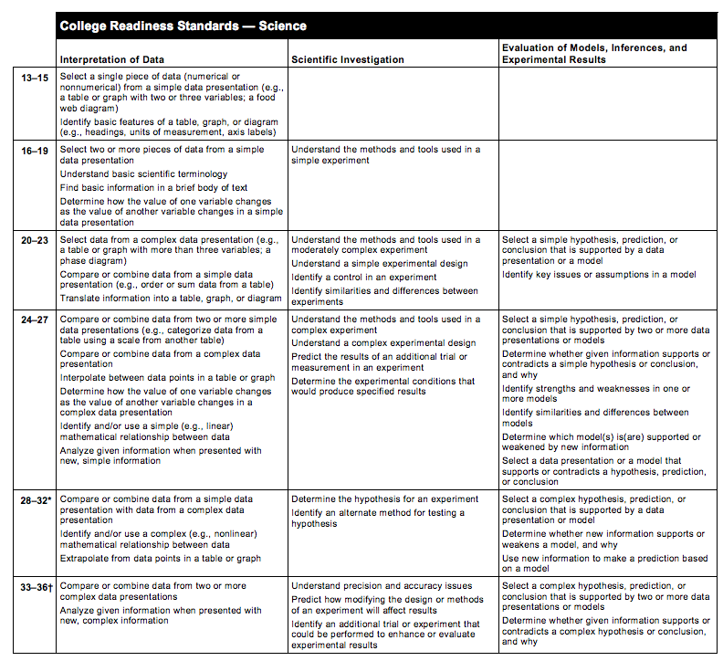
3) Evaluation of Models, Inferences, and Experimental Results

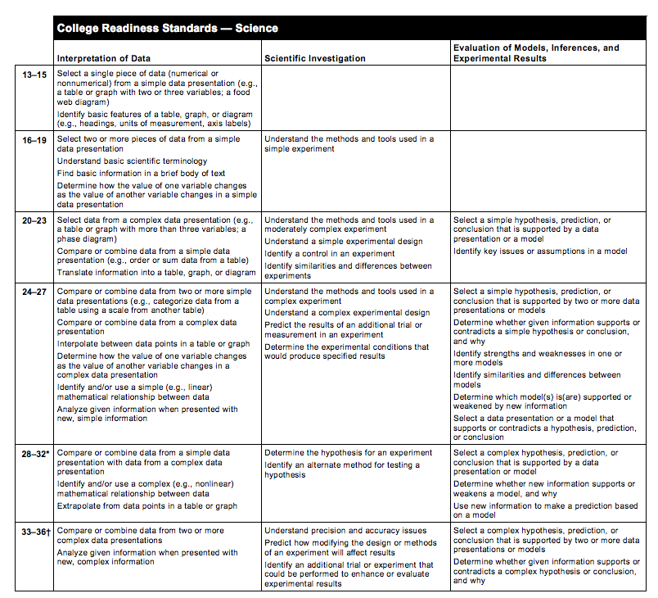
Common Core State Standards

Common Core Reading
Literacy in Science and Technical Subjects
Key Ideas and Details
RST.11-12.1 Cite specific textual evidence to support analysis of science and technical texts, attending to important distinctions the author makes and to any gaps or inconsistencies in the account.
RST.11-12.2 Determine the central ideas or conclusions of a text; summarize complex concepts, processes, or information presented in a text by paraphrasing them in simpler but still accurate terms.
RST.11-12.3 Follow precisely a complex multistep procedure when carrying out experiments,
taking measurements, or performing technical tasks; analyze the specific results based on explanations in the text.
Craft and Structure
RST.11-12.4 Determine the meaning of symbols, key terms, and other domain-specific words and phrases as they are used in a specific scientific or technical context relevant to grades 11-12 texts and topics.
RST. 11-12.5 Analyze how the text structures information or ideas into categories or hierarchies, demonstrating understanding of the information or ideas.
RST. 11-12.6 Analyze the author’s purpose in providing an explanation, describing procedure, or discussing an experiment in a text, identifying important issues that remain unresolved.
Integration of Knowledge and Ideas
RST.11-12.7 Integrate and evaluate multiple sources of information presented in diverse formats and media (e.g., quantitative data, video, multimedia) in order to address a question or solve a problem.
RST.11-12.8 Evaluate the hypotheses, data, analysis, and conclusions in a science or technical text, verifying the data when possible and corroborating or challenging conclusions with other sources of information.
RST.11-12.9 Synthesize information from a range of sources (e.g., texts, experiments, simulations) into a coherent understanding of a process, phenomenon, or concept, resolving conflicting information when possible.

Common Core Writing
Writing for Literacy in Science and Technical Subjects: Research to Build and Present
Knowledge
W.11-12.7. Conduct short as well as more sustained research projects to answer a question (including a self-generated question) or solve a problem; narrow or broaden the inquiry when appropriate; synthesize multiple sources on the subject, demonstrating understanding of the subject under investigation.
W.11-12.8 Gather relevant information from multiple authoritative print and digital sources, using advanced searches effectively; assess the strengths and limitations of each source in terms of the specific task, purpose, and audience; integrate information into the text selectively to maintain the flow of ideas, avoiding plagiarism and overreliance on any one source and following a standard format for citation.
W.11-12.9. Draw evidence from informational texts to support analysis, reflection, and research.

ABSTRACT

The Illinois Junior Academy of Science
This form/paper may not be taken without IJAS authorization.

CATEGORY |  |  |  |  | STATE REGION #
SCHOOL |  |  |  |  | IJAS SCHOOL #
CITY/ZIP |  |  |  |  | SPONSOR CELL PHONE #
SPONSOR |  |  |  |  | SPONSOR E-MAIL
MARK ONE: | EXPERIMENTAL INVESTIGATION |  |  |  |  |  |  | DESIGN INVESTIGATION
NAME OF SCIENTIST* |  |  |  |  |  |  | GRADE
NAME OF SCIENTIST |  |  |  |  |  |  | GRADE
NAME OF SCIENTIST |  |  |  |  |  |  | GRADE
NAME OF SCIENTIST |  |  |  |  |  |  | GRADE
* If this project is awarded a monetary prize, the check will be written in this scientist's name, and it will be his/her responsibility to distribute the prize money equally among all participating scientists.

PROJECT TITLE
Purpose:
Procedure:

Conclusion:

1) Limit Abstract to 3 paragraphs (about 250 words or less). a) Purpose - what you set out to investigate; b) Procedure - how you did it; c) Conclusion - based on your results. Label each paragraph.
2) Must be typed, single-spaced on the front of this form. Do not write on the back of this form.
3) Three copies of your complete paper are required at the State Science Project Exposition.
Four copies of your complete paper are required for the State Paper Session Competition.

This form must be used. This form must be displayed on the front of the exhibitor’s display board. It may be reduced to half a sheet of paper; 8.5 inches (vertical) X 5.5 inches (horizontal).

SAFETY SHEET
The Illinois Junior Academy of Science
Directions: The student is asked to read these introductions carefully and fill out the bottom of this sheet. The
science teacher and/or advisor must sign in the indicated space. By signing this sheet, the sponsor
assumes all responsibilities related to this project.

Safety and the Student: Experimentation or design may involve an element of risk or injury to the student, test
subjects and to others. Recognition of such hazards and provision for adequate control measures are joint
responsibilities of the student and the sponsor. Some of the more common risks encountered in research are
those of electrical shock, infection from pathogenic organisms, uncontrolled reactions of incompatible
chemicals, eye injury from materials or procedures, and fire in apparatus or work area. Countering these
hazards and others with suitable safety practices is an integral part of good scientific research. In the chart below,
list the principal hazards associated with your project, if any, and what specific precautions
you have used as safeguards. Be sure to read the entire section in the Policy and Procedure Manual of the Illinois Junior Academy of Science entitled "Safety Guidelines for Experimentation" before completing this form.

Possible hazards | Precautions taken to deal with each hazard
Specific safety practices related to materials requiring endorsement sheets should be detailed on the specific
endorsement sheet and not included on this safety sheet.

Please check off any other possible endorsements needed. Include these documents in your paper and on your board.
_____Humans as Test Subjects –for any projects involving humans including survey administration;
_____Microorganisms-for any projects involving bacteria, viruses, yeasts, fungi or protazoa;
_____Non-Human Vertebrates -for any projects involving fish, amphibians, reptiles, birds or mammals;
_____Tissue Culture-for any projects involving growing eukaryotic tissues or cell cultures;
_____Letter from institution where research was done or IJAS SRC, if an exception to the IJAS rules has been granted...
SIGNED
Student Exhibitor(s)
SIGNED
Sponsor *
*As a sponsor, I assume all responsibilities related to this project.

This Sheet Must Be Typed and This form must be displayed on the front of the exhibitor’s display board. It may be reduced to half a sheet of paper 8.5 inches (vertical) X 5.5 inches (horizontal).

Humans as Test Subjects Endorsement
The Illinois Junior Academy of Science
These rules will be strictly enforced for the State Science Exposition.
No region should send a project to the State Exposition that does not meet these regulations.
Students and sponsors doing a human vertebrate project must complete this form. The signature of the student or students
and the sponsor indicates that the project was done within these rules and regulations. Failure to comply with these rules
will mean the disqualification of the project at the state level. This form must follow the Safety Sheet in the project paper.

1. Humans must not be subjected to treatments that are considered hazardous and/or that could result in undue stress, injury, or death to the subject.
2. No primary or secondary cultures taken directly (mouth, throat, skin, etc.) or indirectly (eating utensils, countertops, doorknobs, toilets, etc.) will be allowed.
However, cultures obtained from reputable biological suppliers or research facilities are suitable for student use.
3. Quantities of food and non-alcoholic beverages are limited to normal serving amounts or less and must be consumed in a reasonable amount of time. Normal
serving amounts must be substantiated with reliable documentation. This documentation must be attached to the Humans as Test Subjects Endorsement form.
No project may use over-the-counter, prescription, illegal drugs, or alcohol in order to measure their effect on a person.
4. The only human blood that may be used is that which is either purchased or obtained from a blood bank, hospital, or laboratory. No blood may be drawn by
any person or from any person specifically for a science project. This rule does not preclude a student making use of data collected from blood tests not made
exclusively for a science project.
5. Projects that involve exercise and its effect on pulse, respiration rate, blood pressure, and so on are allowed provided the exercise is not carried to the extreme.
Electrical stimulation is not permitted. A valid, normal physical examination must be on file for each test subject. Documentation of same must be attached to
the Humans as Test Subjects Endorsement form.
6. Projects that involve learning, ESP, motivation, hearing, vision, and surveys require the Humans as Test Subjects form.
The signatures of the student or students and sponsor below indicate that the project conforms to the above rules of the
Illinois Junior Academy of Science.
Fill out the following charts:
Were humans given food? If so, was it a serving size or less?
Were humans subjected to exercise? If so, is there evidence of a physical on file for each test subject?
Briefly describe how humans were used in the investigation.

Describe the possible risks to humans test subjects. | Describe how each risk was handled or avoided.

 | (Sponsor)* |  | (Student)
 | (Date) |  | (Student)
 | *As a sponsor, I assume all responsibilities related to this project.

This form must be displayed on the front of the exhibitor’s display board. It may be reduced to half a sheet of paper 8.5 inches (vertical) X 5.5 inches (horizontal).

Check box if exception/approval letter from an institution where research was done, or the IJAS SRC is required and attached.
Non-Human Vertebrate Endorsement
The Illinois Junior Academy of Science

These rules will be strictly enforced for the State Science Exposition.
No region should send a project to the State Exposition that does not meet these regulations.

Students and sponsors doing a non-human vertebrate project must complete this form. The signature of the student or
students and the sponsor indicates that the project was done within these rules and regulations. Failure to comply with these rules will mean the disqualification of the project at the state level. This form must follow the Safety Sheet in the project paper.

1. The student and the sponsor have the responsibility to see that all animals have proper care in well-ventilated, properly lighted locations with proper nutrition,
proper temperature, adequate water, and sanitary surroundings. Care must be taken to see that the organisms are properly cared for during weekends and
vacation periods.
2. No primary or secondary cultures involving warm-blooded animals taken directly ( mouth, throat, skin, etc.) or indirectly (cage debris, droppings, etc.) will be
allowed. However, cultures purchased from reputable biological supply houses or research facilities are suitable for student use.
3. No intrusive or pain- producing techniques may be used. Included in these techniques would be things such as surgery, injections, taking of blood, burning,
electrical stimulation or giving of over-the-counter, prescription, illegal drugs, or alcohol to measure their effect.
4. No changes may be made in an organism’s environment that could result in undue stress, an injury, or death to the animal.
5. No vertebrates can be used as the independent or dependent variables in an experiment that could result in undue stress, an injury, or death to the animal.
6. For maze running and other learning or conditioning activities, food or water cannot be withheld for more than 24 hours. If the animal has a high metabolic rate,
then food or water cannot be withheld for a length of time that would produce undue stress on the animal.
7. Chicken or other bird embryo projects are allowed, but the treatment must be discontinued at or before ninety-six hours from fertilization.
8. Projects that involve behavioral studies of newly hatched chickens or other birds will be allowed if no changes have been made in the normal incubation and
hatching of the organism, and that all vertebrate rules are followed.

Fill out the following charts
Scientific and common name of animal(s) being used.
Brief description of use of the organism(s).

Describe the possible risks to the non-human vertebrates | Describe how each risk was handled or avoided

The signatures of the student or students and sponsor below indicate that the project conforms to the above rules of the
Illinois Junior Academy of Science.
(Sponsor)* |  | (Student)
(Date) |  | (Student)
*As a sponsor, I assume all responsibilities related to this project.
This Sheet Must Be Typed

This form MUST be displayed on the front of the exhibitor’s display board. It may be reduced to half a sheet of paper
8.5 inches (vertical) X 5.5 inches (horizontal).

Check box if exception/approval letter from an institution where research was done, or the IJAS SRC is required and attached.

Tissue Culture Endorsement
The Illinois Junior Academy of Science

These rules will be strictly enforced for the State Science Exposition. No region
should send a project to the state exposition that does not meet these regulations.

Students and sponsors doing a tissue project must complete this form. The signature of the student or students and the sponsor
indicates that the project was done within these rules and regulations. Failure to comply with these rules will mean the disqualification
of the project at the state level. This form must follow the Safety Sheet in the project paper.

1. This area of science may involve many dangers and hazards while experimenting. It is the sole responsibility of all teacher(s)/sponsor(s) to teach students proper safety methods and sterile techniques.
2. The Illinois Junior Academy of Science prohibits the use of primary cell cultures taken from humans or other vertebrate animals in
any project because of the danger from unknown viruses or other disease-causing agents that may be present. Established tissue culture
cell lines that are characterized as requiring biosafety level 1 (BSL1) procedures and precautions may be obtained from reputable
suppliers and used in proper research settings. Cell lines requiring biosafety level 2 (BSL2) procedures and precautions for use must
have approval from IJAS prior to use OR be used in an established research facility.
3. Experiments using tissue culture cell lines must be conducted in a laboratory such as science classroom or research facility.
4. Projects involving tissue culture should be done with the help of a professional and should comply with the standards and principles
for biological safety.
5. Experiments using tissue culture, including the culture of insect cells, with viruses and/or recombinant DNA must also follow the
rules and regulations for these agents; one endorsement sheet detailing use of these agents together is acceptable.
6. All cultures should be destroyed by methods such as autoclaving or with a suitable NaOCl (bleach) solution before disposal.

Fill out all boxes in the chart below:
Published name of
cells or tissue used
Source from where the
cells or tissues were obtained
Cell disposal method used

Brief description of how cells were used

Safety precautions taken

The signatures of the student or students and sponsor below indicate that the project conforms to the above rules of the
Illinois Junior Academy of Science.
(Sponsor)* |  | (Student)
(Date) |  | (Student)
*As a sponsor, I assume all responsibilities related to this project.

This form must be displayed on the front of the exhibitor’s display board. It may be reduced to half a sheet of paper 8.5 inches
(vertical) X 5.5 inches (horizontal).
Check box if exception/approval letter from an institution where research was done, or the IJAS SRC is required and attached.

Microorganism Endorsement

The Illinois Junior Academy of Science

These rules will be strictly enforced for the State Science Exposition.
No region should send a project to the State Exposition that does not meet these regulations.
Students and sponsors doing a microorganism project must complete this form. The signature of the student or students and
the sponsor indicates that the project was done within these rules and regulations. Failure to comply with these rules will
mean the disqualification of the project at the state level. This form must follow the Safety Sheet in the project paper and on the project board.

1. This area of science may involve many dangers and hazards while experimenting. It is the sole responsibility of all teacher(s)/sponsor(s) to teach students proper
safety methods and sterile techniques.
2. The Illinois Junior Academy of Science prohibits the use of primary or secondary cultures taken from humans or other vertebrate animals in any project because
of the danger from unknown viruses or other disease-causing agents that may be present. Pure cultures of microorganisms known to inhabit vertebrate animals may
be obtained from reputable suppliers and used in proper settings.
3. Microorganism experiments must be conducted in a laboratory such as science classroom or research facility.
4. Projects involving viruses and recombinant DNA should be done with the help of a professional and should comply with the National Institutes of Health (NIH)
Guidelines unless the project is limited to a kit obtained from a legitimate supply house.
5. All cultures should be destroyed by methods such as autoclaving or with a suitable NaOCl (bleach) solution before disposal.

Complete all boxes of the following chart.
Genus and species of
organism(s) being used.
Name of the reputable
source that the organism(s)
were supplied from.
Method of disposal of
the organism(s) being used.
List the location where the
lab work was conducted.
Describe the use of
microorganisms in this
project.
Other precautions taken
to ensure microorganisms
are used safely in this
investigation.

The signatures of the student or students and sponsor below indicate that the project conforms to the above rules of the
Illinois Junior Academy of Science.
(Sponsor)* |  | (Student)
(Date) |  | (Student)
*As a sponsor, I assume all responsibilities related to this project.
This Sheet Must Be Typed
This form must be displayed on the front of the exhibitor’s display board. It may be reduced to half a sheet of paper
8.5 inches (vertical) X 5.5 inches (horizontal).

Check box if exception/approval letter from an institution where research was done, or the IJAS SRC is required and attached.

ESSAY COVER PAGE
The Illinois Junior Academy of Science

CATEGORY: |  |  |  | STUDENT OFFICER ESSAY |  |  | STATE REGION #
(Mark X in Box) |  |  |  | OTHER
NAME: |  |  |  |  |  |  |  | GRADE:
ADDRESS: |  |  |  |  |  |  |  | AGE:
CITY/ZIP:
PHONE:
SCHOOL: |  |  |  |  |  |  |  | IJAS #:
ADDRESS:
CITY/ZIP:
PHONE:
SPONSOR
ESSAY TITLE:
STUDENT SIGNATURE:
SPONSOR SIGNATURE: |  |  |  |  | _____________________________________________________
REGIONAL CHAIR NAME:
REGIONAL CHAIR PHONE AND EMAIL

THIS SHEET MUST BE TYPED

Illinois Junior Academy of Science Regions

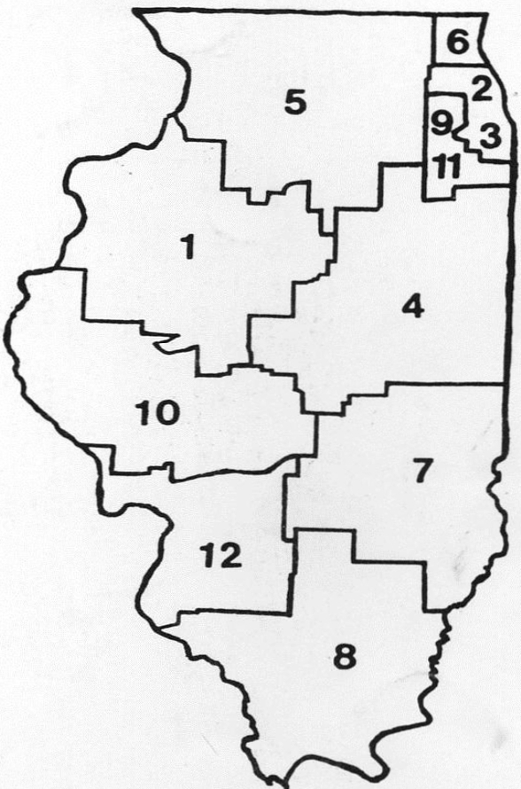
ILLINOIS JUNIOR ACADEMY OF SCIENCE

Region 1 - Central
Fulton, Henderson, Henry, Knox, Marshall, Mason, McDonough, Menard, Mercer, Peoria, Rock Island, Stark, Tazewell, Warren,
and Woodford Counties.

Region 2 - Chicago and Metropolitan Area Non-Public Schools
East of Route 83, North of Route 12/20, South of I-90 to O'Hare Field, West of Lake Michigan.

Region 3 - Chicago Public Schools

Region 4 - East Central
Champaign, DeWitt, Ford, Grundy, Iroquois, Kankakee, Livingston, Logan, Macon, McLean, Piatt, and Vermillion Counties.

Region 5 - Northern
Boone, Bureau, Carroll, DeKalb, Jo Davies, Kane, Kendall, LaSalle, Lee, McHenry, Ogle, Putnam, Stephenson, Whiteside, and Winnebago Counties.

Region 6 - North Suburban
North Half of Cook and DuPage Counties (Route 20 extended is the dividing line), and Lake County.

Region 7 - Southeastern
Clark, Clay, Coles, Crawford, Cumberland, Douglas, Edgar, Edwards, Effingham, Fayette, Jasper, Lawrence, Moultrie, Richland, Shelby, and Wabash Counties.

Region 8 - Southern
Alexander, Franklin, Gallatin, Hamilton, Hardin, Jackson, Jefferson, Johnson, Marion, Massac, Perry, Pope, Pulaski, Randolph, Saline, Union, Wayne, White, and Williamson Counties.

Region 9 - South Suburban
Southern Half of Cook and DuPage Counties (Route 20 extended is the dividing line) and Will County.

Region 10 - Southwestern
Adams, Brown, Calhoun, Cass, Christian, Green, Hancock, Macoupin (North of Route 16), Montgomery (North of Route 16), Morgan, Pike, Sangamon, Schuyler, and Scott Counties.

Region 11 - Joliet Area Non-Public Schools
DuPage, Grundy, Kankakee, Kendall, and Will County Parochial and Private Schools.

Region 12— Edwardsville Area
Bond, Calhoun, Clinton, Jersey, Macoupin (South of Route 16), Madison, Monroe, Montgomery (South of Route 16), St. Clair, and Washington Counties.

