ST. DAMIAN SCHOOL
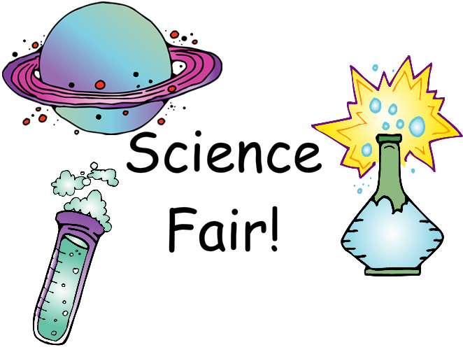
JUNIOR HIGH SCIENCE FAIR
MARCH 9, 2017
It is time to start planning for our Junior High Science Fair. Projects will be completed individually or in pairs. You may want to use a journal to record all information for your experiment.
SCIENCE PROJECT STEPS
- CHOOSE A TOPIC. Be sure it interests you. Don’t pick one because you think it will be easy. Talk it over with your parents and/or your partner and when you have decided, inform your teacher.
- ASK A SPECIFIC QUESTION. State your purpose as a question. What is it that you want to find out by doing this project? For example: Does the quality of nail polish differ with price?
- RESEARCH YOUR PROBLEM. Conduct research to find out about the topic. Look at any books/websites that might help you, make observations by simply looking at things, talk to people, and find out as much as possible about your topic. Write down any ideas you have and where you got them. Also, keep note of all information needed for citing your resources.
- WRITE A HYPOTHESIS. What do you think is going to happen? Based on what you know or found out from step #3, what do you think the results of your experiments will be? After doing the experiments, it may turn out that your guess was wrong. It is okay if this happens. Example: I think that the more expensive nail polish is, the better the quality.
- PLAN/CREATE YOUR DESIGN AND PROJECT. Make a plan for your experiment, to answer the question with measurable data. How will you test your hypothesis? What experiments will you do? How will you measure the results? Where will you keep your information? Be sure to keep notes and write down everything you do and what happens. You may want to make a chart.
- COLLECT ALL OF YOUR MATERIALS. Find a place to keep things where others won’t bother them. Make sure to write down what materials you are using.
- CONDUCT YOUR EXPERIMENT/TEST YOUR DESIGN. Remember, the more times you do an experiment the more reliable and accurate the results will be. Do each experiment at least three times and get an average of the results to use in a graph. Use something to measure your experiments: a ruler or yardstick if you are measuring distance, a clock to measure time, etc.
- RECORD YOUR DATA. As you do your experiments, you will want to write down what you saw or found out. Organize this information in an orderly manner. Put the date, time, and any other useful information.
- RESULTS. Make careful observations and record in your journal. What did you learn from your experiments? Have you proved or disproved your hypothesis? You made a guess about what you thought would happen. Now tell what really did happen.
- CONCLUSION: Answer your Question based on your results.
- PREPARE DISPLAY: Prepare your titles, charts, graphs, drawings, and diagrams. Make them large enough to see, neat, and colorful.
- CONSTRUCT DISPLAY. Get your cardboard display board from your teacher. Boards will be sold at school. A price for the boards and due date for the money will be given to you at a later date.
- PRESENTATION PREPARATION. Be able to tell about what you used what you did in your experiments, and what you found out.

SCIENCE FAIR PROJECTS ARE DUE IN CLASS
ON MARCH 3, 2017.
Most of the project will be done at home. Days in class may be given to work on poster board.

RELAX AND ENJOY! I CAN’T WAIT TO SEE ALL OF YOUR EXPERIMENTS!
Mrs. Jones
B_jones@stdamianschool.org

*Helpful website: (students were shown this website in class)
www.sciencebuddies.org

PLANNING WORKSHEET
NAME(S):__________________________________________ GRADE: ____________
TITLE:___________________________________
QUESTION:
_______________________________________________________________________
HYPOTHESIS:
_______________________________________________________________________
MATERIALS:
_____________________________ _____________________________ _____________________________ _____________________________ _____________________________ _____________________________ _____________________________ _____________________________ _____________________________ _____________________________
EXPERIMENT DESIGN/PLAN:

_______________________________________________________________________
_______________________________________________________________________
_______________________________________________________________________
_______________________________________________________________________
_______________________________________________________________________
_______________________________________________________________________
RESULTS: (HOW WILL YOU SHARE YOUR OBSERVATIONS):
Photos Drawings Tables Graphs Other

DISPLAY BOARD REQUIREMENTS:
All students are required to prepare a display for their project. Tri-fold boards will be sold at school prior to the fair. Students will purchase one board per project. Price and date of availability will be given at a later date. The display board should include the following titles and information:
Title of Project, Student Name(s), Grade, Question, Hypothesis, Research, Procedure/Steps, Results (in the form of charts, graphs, etc.), pictures of experiment process, Conclusion/Analysis (answer to the question).
Students may display additional materials on the table or on board, including experiment design, journal, pictures, other observations, and any additional research.
